**Inclusive Game Design Project**

**A1: Explain and justify the need for a solution**

In many school sports activities, students of different abilities may feel excluded or overwhelmed due to the rules or physical demands of the games. Traditional games like football and basketball can be competitive and skill-based, which can make it difficult for all students to feel confident, included, or actively involved.

There is a clear need for a new game that merges familiar skills from both sports while focusing on inclusion, adaptability, and cooperation. By designing a hybrid game that combines elements of basketball and football and includes adaptable rules, equipment modifications, and progression strategies, we can create a more welcoming and fun experience for everyone, regardless of their skill level.

This inclusive game will allow students to participate more equally, build confidence, and develop a sense of teamwork and community, which aligns with the values of both Physical and Health Education (PHE) and Design.

**A2: Identify and prioritize primary and secondary research**

**Primary research:**

Surveyed classmates through a questionnaire about what makes games fun or frustrating.

**Questionnaire Topics:**

* + Pros and cons about basketball and football
  + Rules that could make the game more fun
  + Preferred scoring method (e.g., goal, throw, tag)
  + Preference: indoor or outdoor play

**🧠 Summary of Findings:**

|  |  |  |
| --- | --- | --- |
| Topic | Insights from Responses | |
| Pros of basketball | Passing, shooting, arm exercise, teamwork, fun to play | |
| Cons of basketball | Makes hands dirty, tiring, physical contact issues | |
| Pros of football | Leg movement, cool tricks, passing, strategies | |
| Cons of football | Risk of getting kicked, physical roughness | |
| Fun rule ideas | Tagging players, fair play, soft gameplay, more steps allowed | |
| Scoring preference | Mixed opinions – some prefer tagging, some like kicking into a goal, others like shooting/throwing | |
| Location preference | Mixed – many preferred **indoors** for comfort and safety, others liked **outdoors** for space | |
|  | |

**Conclusion Based on Questionnaire:**

* + The **new inclusive game** should include a balance of skills from both basketball (e.g., **passing and shooting**) and football (e.g., **kicking**).
  + Students enjoy **tag-based elements**, so including tagging as part of gameplay could increase fun.
  + Safety is important: players want rules that **avoid physical harm**, such as:
  + No aggressive kicking
  + Soft and respectful play
  + Balanced teams (not stacking skilled players on one side)
  + Equipment and rules should be **flexible** and adjusted based on the players' skill levels.
  + This student feedback gave me direct insight into what players enjoy and what should be avoided, helping me design a more **inclusive, fair, and enjoyable** game.
* **Secondary research:**
  + Researched existing inclusive sports and modified games.
  + Looked into official rules for basketball and football to understand the core mechanics of each.

**A3: Analyze Existing Products**To gather inspiration and guidance, I analyzed several existing inclusive games, focusing on how they balance skill, teamwork, and fairness. These games often feature simplified rules, clear player roles, and objectives that promote cooperation over competition. By studying these examples, I learned that successful inclusive games:

* Use straightforward, easy-to-understand rules.
* Clearly define roles to support all ability levels.
* Encourage teamwork rather than individual performance.
* Minimize elimination so everyone stays involved.

To visualize these insights, I created a Venn diagram comparing basketball, football, and my own game. The diagram helped me identify key characteristics that I wanted to incorporate into my game, such as:

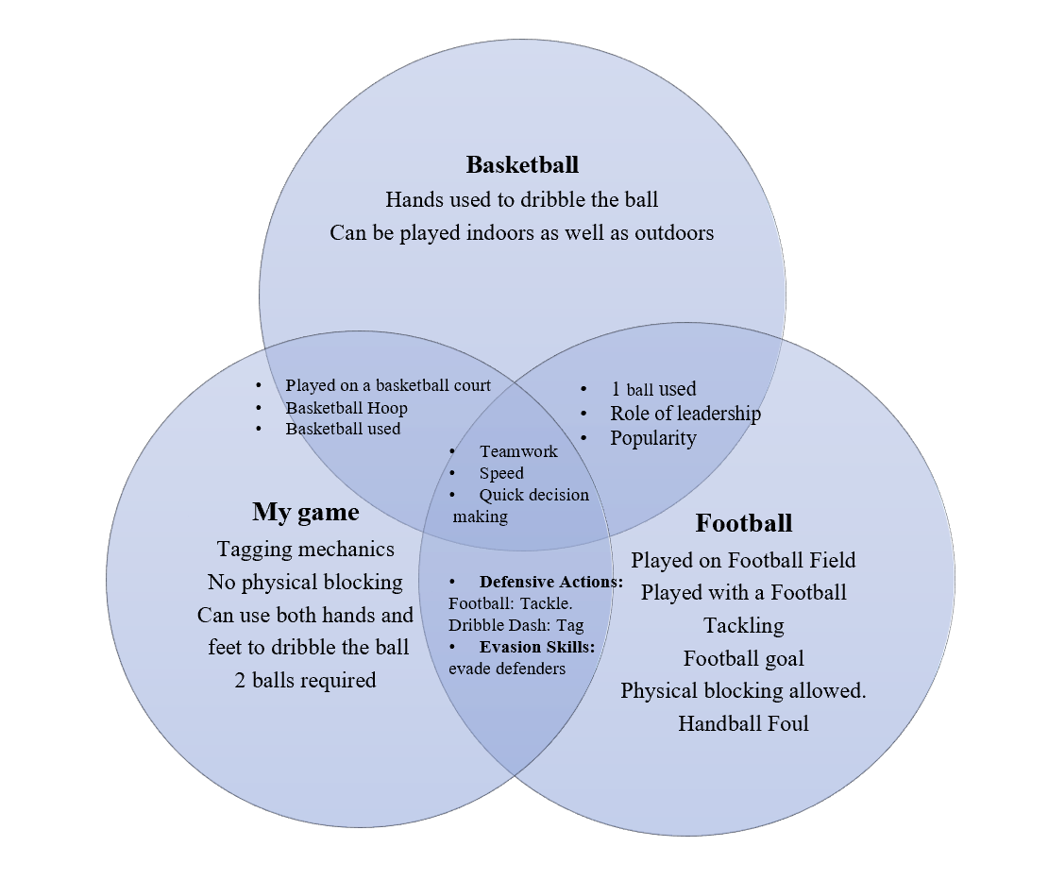

This analysis, combined with the Venn diagram, helped shape my game by emphasizing accessibility, enjoyment, and active involvement for all players.

**A4: Develop a design brief**

A hybrid game will be designed that combines fundamental skills from both football (like passing and footwork) and basketball (like dribbling and shooting) in a way that is inclusive and adaptable for students with different abilities. The game will feature flexible rules to match different skill levels, modified equipment to make the game safer and more accessible, a clear skill progression guide for learning and improving, and strategies to ensure balanced participation. The design will promote teamwork, fairness, and enjoyment while keeping students active and engaged.

**💡 Criterion B: Developing Ideas**

**B1. Develop Design Specification**

|  |  |
| --- | --- |
| Feature | Specification description |
| Accessibility\ | Suitable for all students regardless of skill level. |
| Safety | Tagging only allowed, no physical contact. |
| Simplicity | Rules are easy to learn and follow. |
| Engagement | Keeps all players active and participating. |
| Flexibility | Can be played indoors or outdoors. |
| Skill development | Focuses on dribbling, agility, and spatial awareness. |
| Equipment | Uses basic pe equipment like basketballs and cones. |
| Inclusivity | Rules allow different roles for varied skill levels. |

**B2. Generate a Range of Ideas**

|  |  |  |  |  |
| --- | --- | --- | --- | --- |
| Idea # | Description | Key Rules | Scoring System | Unique Twist |
| 1 | Game played on a basketball court involving tagging opponents in the central zone | Tag opponents in the central zone to score; ball can be passed by kicking | +Points for tagging, -2 points if opponent gets hurt | Passing by kicking instead of throwing |
| 2 | Game played on a soccer field where each team has its own ball to score a goal on the opposite side | Move your ball to the opposing goal while avoiding getting tagged | Winning team is the first to score without getting tagged | Each team has its own ball; tag-based interference |
| 3 | Indoor game with a light leather ball and tag zones | Players move the ball across while avoiding tags in certain regions | Likely point-based on successful crossing | Tag zone in specific regions adds strategy |
| 4 | Basketball + football hybrid with tagging and penalties | Dribble like basketball, pass and score like football; tag to send opponents to a penalty box | Not specified; penalty and scoring system implied | 30-second penalty box via tag; multi-sport mechanics |
| 5 | Deception game with real and fake balls | Only referee knows real ball; tagged players learn but must stay silent | Likely score using real ball; deception adds depth | Referee-controlled truth, silent knowledge after tagging |
| 6 | Basketball court game with tagging and shooting | Score by tagging or making 3-point shots only | Points from tags and successful 3-pointers | Only 3-point shots count — strategic scoring |
| 7 | Dribble-based tagging game on a basketball court | Players must dribble into opponent’s paint while avoiding tags | Score by reaching the paint safely | Emphasizes dribbling under pressure and defensive tagging |
| 8 | Accessibility-inspired football goal game | One team rolls footballs from penalty box; opposing team defends | Score by rolling footballs into goal | Rolling mechanic; inclusive gameplay design |
| 9 | Chain-formation game with team sabotage | Team must form an unbroken chain to score; teammates can break chain from the middle | Must restart chain if broken | Physical coordination + internal sabotage twist |

**B3. Develop a Final Chosen Design**

**🏀 Game Title: Dribble Dash**

**🎯 Objective**

Each team must dribble a basketball across to the opponent's paint (key area) without being tagged by defenders. Points are awarded for each successful dash through the paint. The team with the most points at the end wins.

**👥 Teams**

* Two teams of 5–7 players each.
* Divide players equally

**🧠 Skills Developed**

* Dribbling under pressure
* Agility and evasion
* Defensive positioning
* Teamwork and spatial awareness
* Decision-making and timing

**🧰 Equipment Needed**

* Basketball court
* 2 basketballs (1 per team)
* Whistle and stopwatch

**📏 Setup**

* Each team starts on their own half with a basketball.
* The paint area (key) on the opposite side is the goal zone for scoring.
* Tagging is only allowed when players enter the opponent's half.

**📜 Rules**

1. **Dribbling Required**  
   Players must continuously dribble the basketball when moving. If they stop dribbling, they return to their side and restart.
2. **Tagging Mechanics**  
   Defenders (players on their own side) may tag any opponent entering their half.
   * Tag = Out → Tagged players return to their side and try again.
3. **Scoring a Point**A player scores 1 point for their team if they dribble into the opponent's paint area without being tagged. After scoring, they return to their side.
4. **Team Play**  
   Multiple players can attack at once to create distractions and confuse defenders.
5. **Time Limit**  
   The game can be played in 2 halves of 10 minutes, or a total of 20 minutes.
6. **No Physical Blocking**  
   Defenders may only tag, not block or hold players.

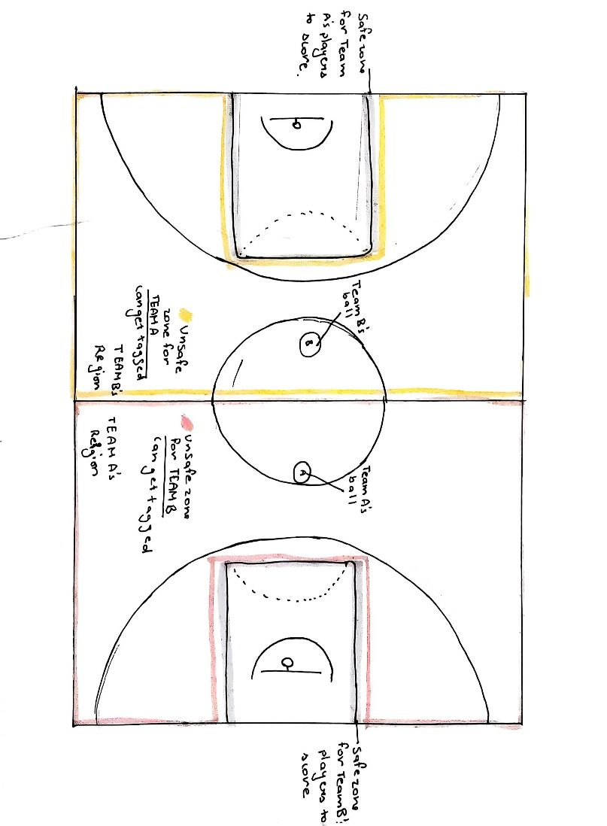

**🎮 Gameplay**

**•** Players dribble into the opponent’s paint to make a shot and score 1 point.  
• Defenders tag attackers in their half.  
• Tagged players return and try again.  
• Team with more points wins!

**✅ Safety Tips**

* Use soft tags (like touch on shoulder).
* Encourage sportsmanship.
* Referee or teacher supervises fairness.