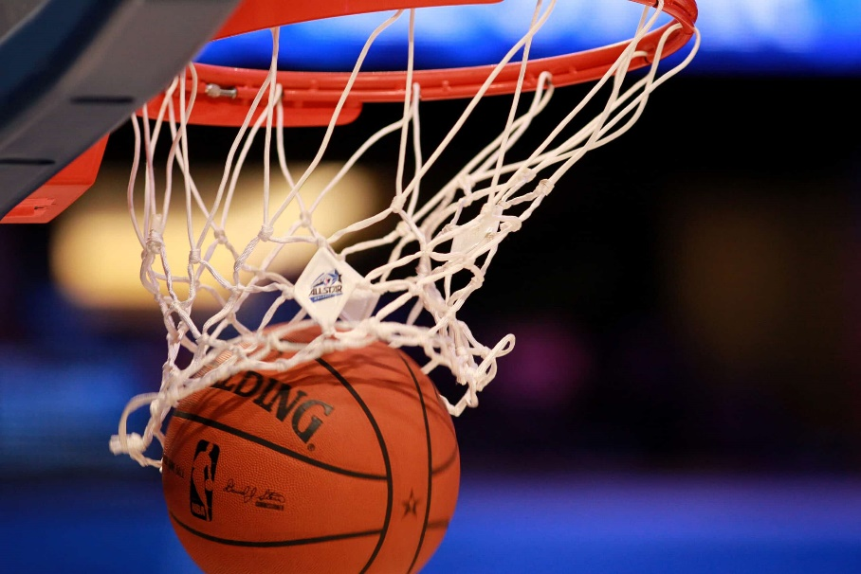Design

New

Games

Combine

Basketball

And

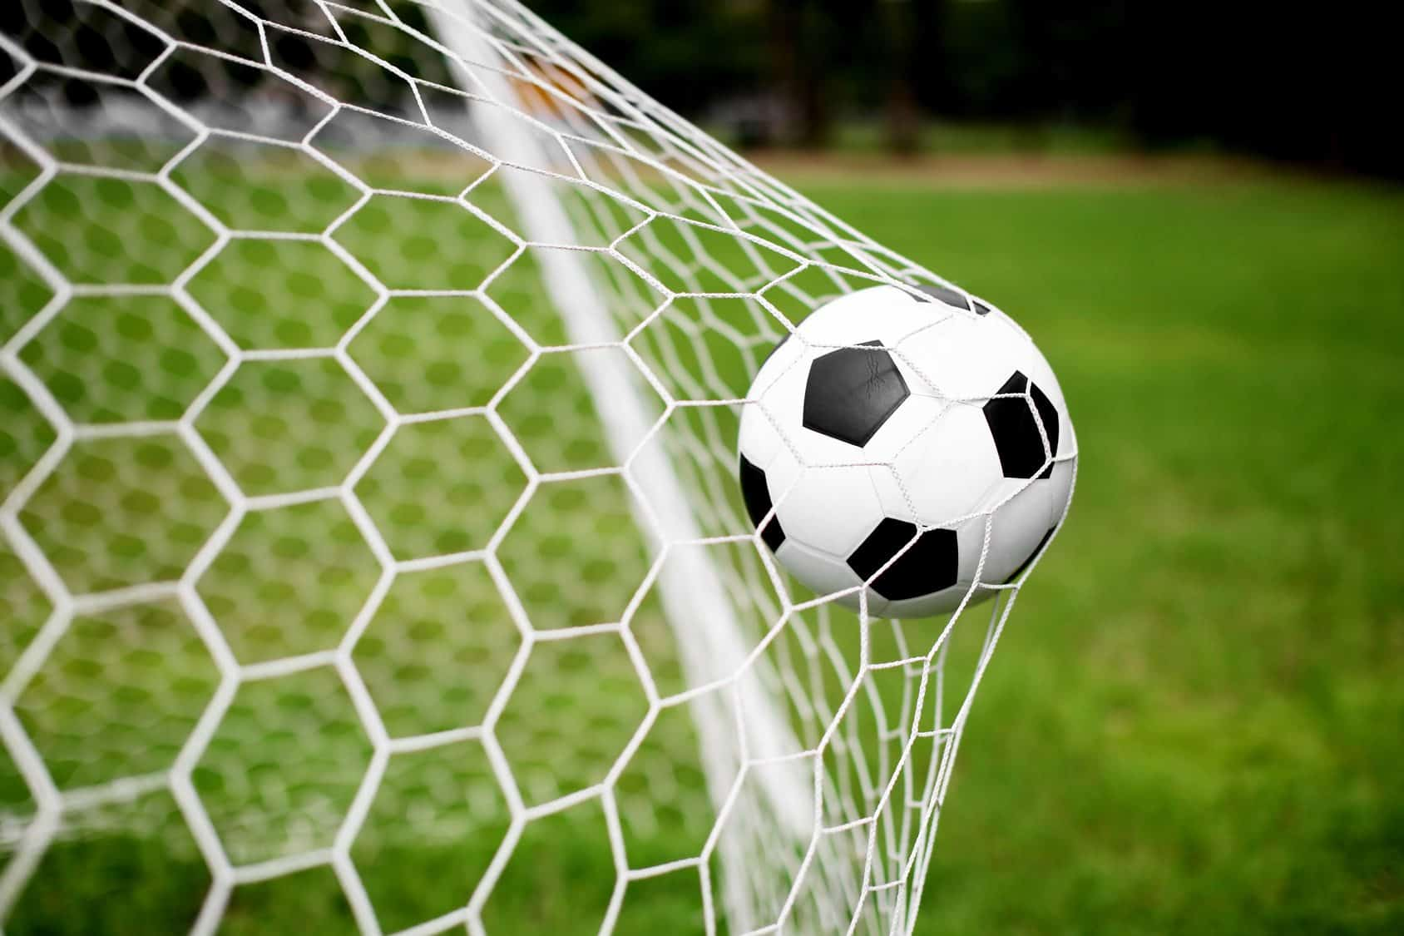Football

TABLE OF CONTENT

|  |  |
| --- | --- |
| Content | Page |
| Criterion A: Inquiring and Analysing |  |
| Explain and Justify the Need |  |
| Identify and Prioritise the research |  |
| Analyse Existing Product |  |
| The result of the survey |  |
|  |  |
|  |  |
|  |  |
|  |  |
|  |  |
|  |  |
|  |  |
|  |  |
|  |  |
|  |  |
|  |  |
|  |  |
|  |  |
|  |  |
|  |  |
|  |  |

Criterion A: Inquiring and Analysing

Explain and Justify the Need

In the sports realm, basketball wins fans over with rapid offense - defense shifts and precise shooting. Soccer gains global popularity for its vast playing field and intense rivalries. Dodgeball offers a distinctive thrill through nimble dodging and bold throws. Merging these three sports to design a new game not only creates novel gameplay, enriches the sports experience, but also propels the development of sports culture. This integration breaks the monotony of traditional sports, delivering a more thrilling experience. Basketball emphasizes hand - ball control and shooting, soccer focuses on foot - dribbling and goal - scoring, and dodgeball centers around dodging and throwing. During gameplay, players must coordinate hands and feet, adroitly switching skills. For example, they dribble the ball to a set area following soccer rules, then switch to basketball - style shooting. When facing dodgeball attacks, they dodge promptly. The combination of multiple skills enriches the game, providing enjoyment far beyond that of single - sport games.

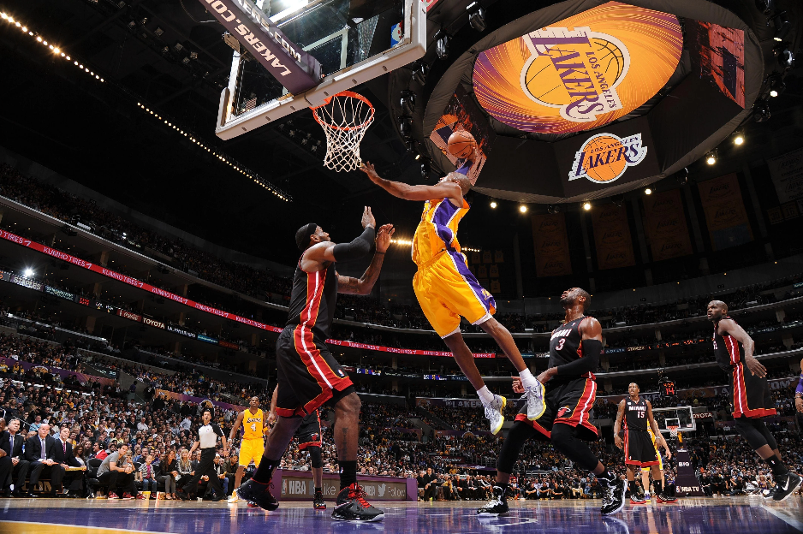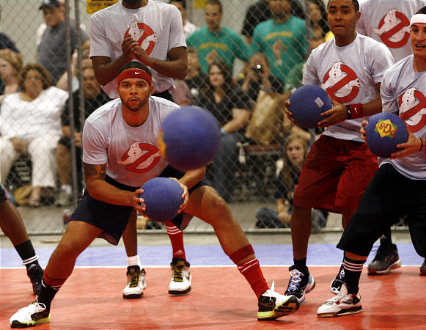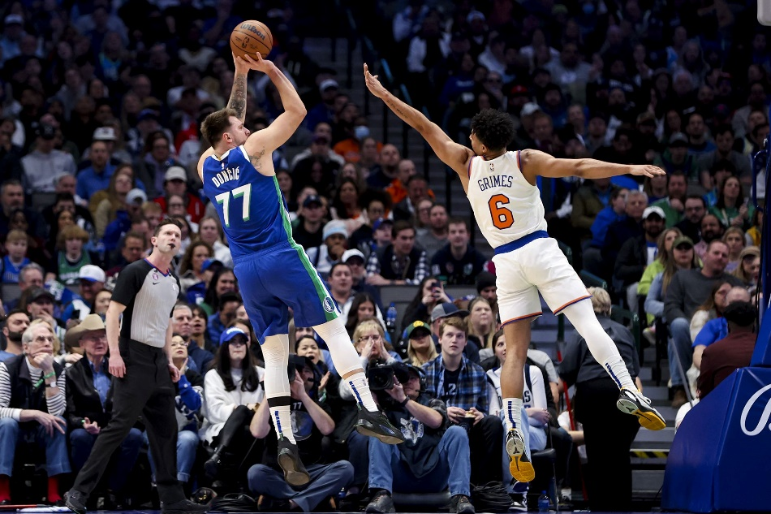

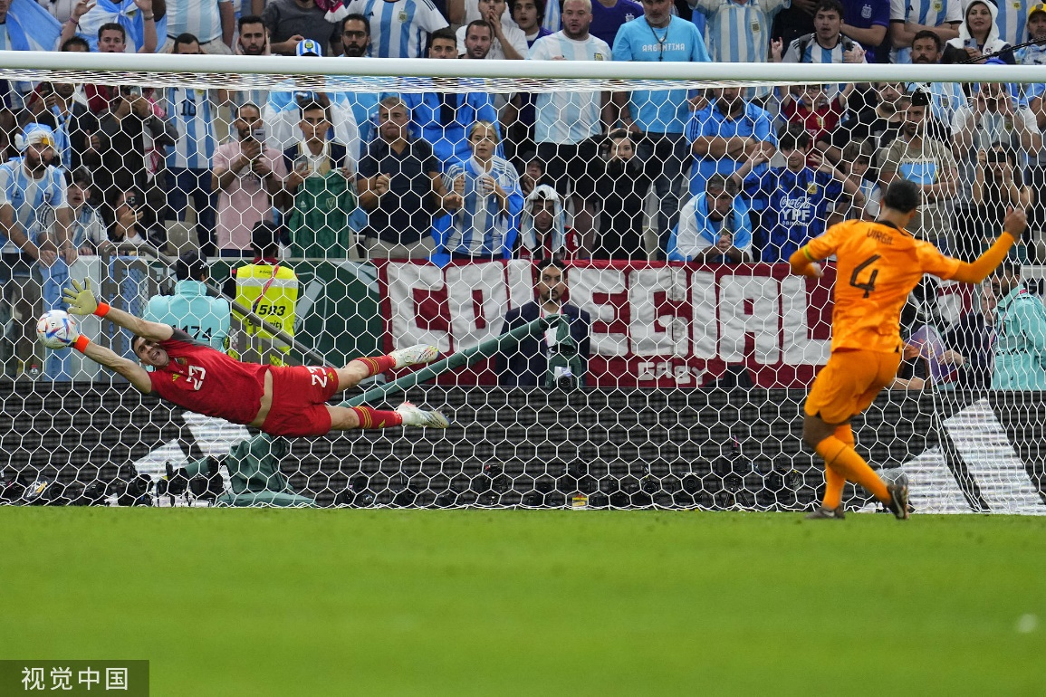

|  |  |  |
| --- | --- | --- |
| Research Area | Description | Priority Level |
| Safety  factors | Analyze the potential safety risks in the game. For example, getting injured from being hit by a ball, tripping over a hula hoop, and colliding with others while evading dodgeballs. | High |
| Player  experience | Survey the expectations and acceptance of players of different ages and athletic levels for the game, and study methods to enhance the game's fun, challenge, and fairness. | Medium |
| Venue  and  Equipment | Design the specifications and layout of the venue suitable for the new game, and develop suitable equipment, such as balls with appropriate size and function. | Medium |
| Game Rules  and  Mechanisms | Research on how to integrate the rules of the three sports, covering aspects like the scoring system and the timing for introducing dodgeball, etc. | Medium |

 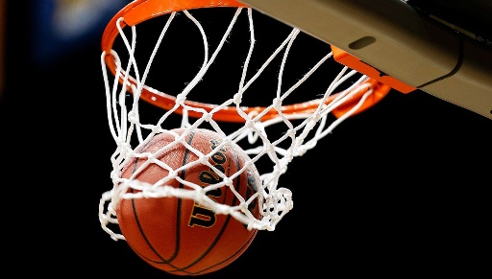 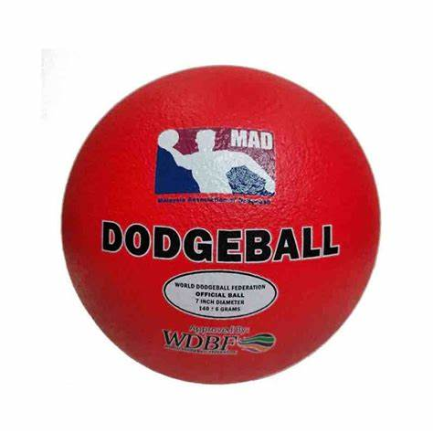

The result of the survey

|  |  |
| --- | --- |
|  | Number of students |
| Who like playing basketball | 2 |
| Who like playing football | 4 |
| Who is good at basketball | 2 |
| Who is good at football | 2 |
| Who likes using feet to play | 1 |
| Who likes using feet and hands to play | 5 |
| Who thinks basketball is harder | 3 |
| Who thinks football is harder | 1 |

Two students want 6 people in a team.

One student wants >10 people in a team.

One student wants 11 people in a team.

One student wants <8 people in a team.

One student wants 5 people in a team.