Team members

Soren

Jason

Arya

Reuben

01/04/2025 Made a WeChat group so we can discuss ideas.

Possible names for our game:

1. GridBall
2. BounceNet
3. GridGoal
4. NetRush
5. BoundZone
6. ZoneBall

We decided on Grid Ball by voting on WeChat.

Field/Court

The court is a grid with squares and with narrow boundaries between each of the squares. There is a net on the left and the right of the court for scoring.

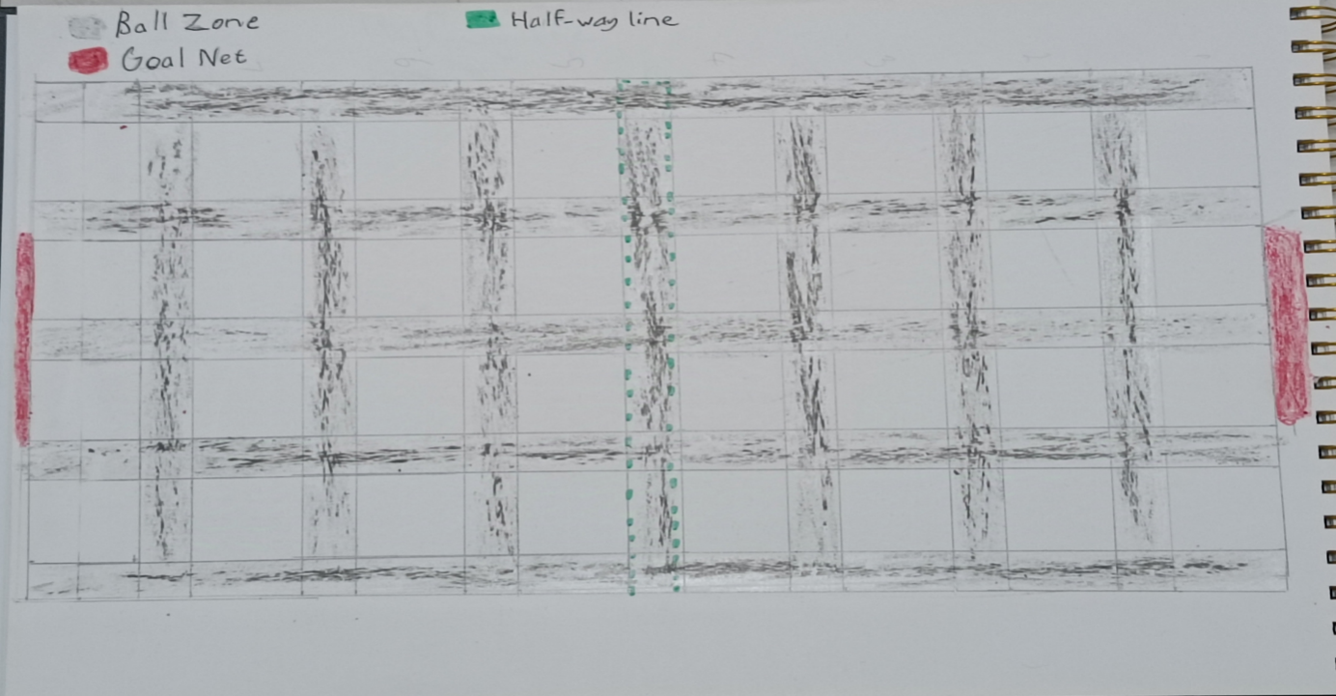

Objective

Teams must bounce a ball on the narrow boundaries called the Ball Zone so that they can score a goal by throwing the ball into the net at the opposite end. Each goal is worth 1 point. Winner is the team with the most points after 15 minutes.

Players

Two teams, each team has five members.

2 x Defenders

2 x Attackers

1 x Goal Keeper

Rules

The players can only move on the narrow boundaries (Ball Zone) between squares and cannot step into the squares. Except for the Goal Keeper.

The player with the ball can only bounce the ball within the Ball Zone(narrow boundaries).

The player can only throw the ball to another player.

If the ball lands on a square it can be picked up by any team but no one can step into the square to get it.

Attackers can only stay on the other team’s half of the court.

Defenders cannot leave their half of the court.

Goalkeepers can only move along the squares directly in front of the goal net. But they cannot step in the Ball Zone at all.

If a player steps into a square they are out of the game for two minutes. If a goalkeeper steps into the Ball Zone he is out of the game for two minutes.

Referees

There are going to be 4 referees

1. Attacker referee-Arya
2. Defender referee-Reuben
3. Goal keeper referee-Jason
4. Timer referee-Soren

Each referee will give the player who broke the rules a “GET OFF THE GRID” card. The Player will then give the card to the timer referee who will set the timer to 2 minutes.

When the timer runs out, the timer referee will give the card back to the player.

The player returns the card to the referee who gave it to him in order to return to the grid.

The referees will be wearing a black T-shirt with a blue armband.