NAME: Alynah

DATE: 24mar2025

OBJECTIVE: The objective of this IDU is to design a game that combines basketball and soccer. It has to be available for everyone to play and fun. By designing the game according to the results of my questionnaire.

: My team and I (Joa, Rebecca, Mihika and I) made a ‘final’ design for the game. Each person had a different job to contribute to making the game: I had the rules, Mihika had to make the explanation and Rebacca did the equipment and skills, Joa is the referee.

DESIGN CYCLE:

>Explain and justify the need- A game that combines basketball and soccer, fun and available for everyone to play.

>Identify and prioritize the research- Research the rules and skills of basketball and soccer.

>Analyze existing products- look at the rules and skills of basketball and soccer.

>Develop a design brief- A game that combines basketball and soccer, fun and available for everyone to play.

>Develop a design specification- The Venn diagram.

>Develop design ideas- I developed 3 different ideas for my game.

>Present the chosen design- I merged the ideas to make the final one.

>Develop planning drawings/diagrams- In the final idea.

>Constuct a logical plan- Rebacca, Joa, Mihika and I got into a group and chose 1 game design (Rebecca’s chosen game design).

>Demonstrate technical skills- We elaborated on the game, added more details, created a field and made an explanation.

>Follow the plan to make a solution-

>Justify changes made to the design- We made more changes to the game and added more details, like measurements, once Mihika came back

>Design testing methods-

>Evaluate the success of the solution-

>Explain how the solution could be improved-

>Explain the impact of the solution-

# PORTFOLIO

# FOR

# GAME DESIGN

# INDEX

**Objective 1**

**Inquiring And Analysing 1**

**Developing Ideas 3**

**Creating The Solution 5**

**Evaluating 6**

## OBJECTIVE: Create a game that combines basketball and soccer skills and is accessible for everyone to play.

# INQUIRING AND ANALYSING

To see what I needed to add in my game, I posted a questionnaire to see what the students like in sport games. These are the questions I asked:

1. What do you like about soccer?
2. What do you like about basketball?
3. Would you prefer more soccer or basketball skills in a game?
4. Would you prefer a game indoors, outdoors or both?
5. Would you prefer a game about capturing something or making a goal?

From the all the answers I got I notice each person likes something different about soccer and most people like shooting in basketball. Most people would prefer more basketball skills in a game. More people prefer games indoors. The number of people who choose capturing something and making a goal was equal.

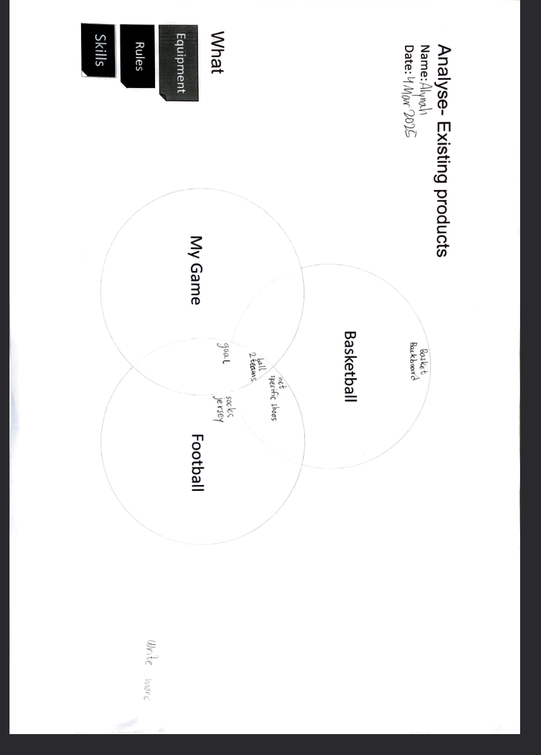

I made the Venn diagram above to get a head start for thinking of ideas. I thought if the following:

Basketball + soccer: Net, Specific shoes

Soccer: Socks, Jersey

Soccer + my game: Goal

Basketball + soccer + my game: Ball, 2 teams

**DEVELOPING IDEAS**

I had developed 3 sample ideas to start with and merged all of them to develop further:

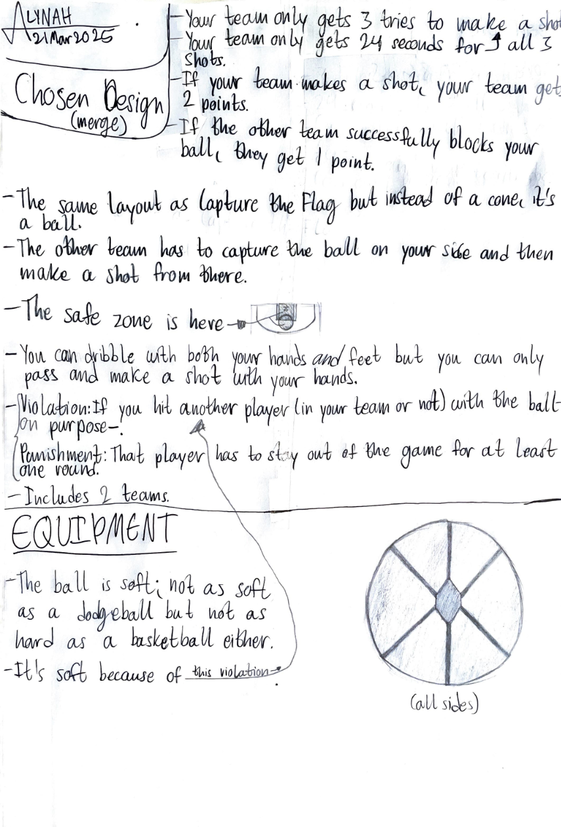

The rest of my team (Joa, Rebecca, Mihika and I) did the same. Some of them even came up with more than 3 ideas. At this stage, even for the 3 sample ideas, we were only writing ideas and points fro the game, not the whole game.

**CREATING THE SOLUTION**

Once we each had a chosen design, we chose one of their chosen designs and we ended up choosing Rebecca’s. That was our final group design:

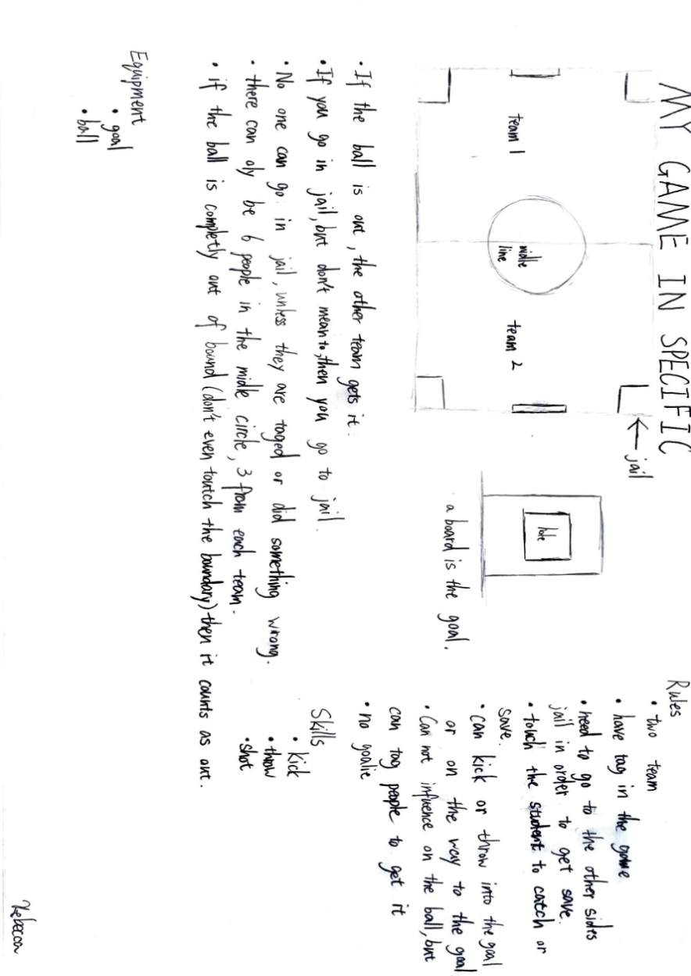

We then elaborated it and added more rules, equipment, details, etc. We also decided the measurements for the equipment.

**EVALUATING**

We played the game with the whole grade 6-9 and got feedback from them about the game. We asked a few questions and everyone answered them:

The questions:

Do you like the game?

Is it boring?

Is it hard and/or challenging?

Do you want to play it again?

What do you hate about it?

What part of the game do you enjoy most and why?

How did the game make you feel while playing?

If you could change one thing about the game, what would it be?

Was the game fair? Did everyone have an equal chance to succeed?

Was the game too short, too long or just right?

The answers:

Most people liked the game and didn’t think it was boring. Most people didn’t think the game was hard. They weren’t sure if they wanted to play it again, though. The things people hate the most about the game was the hoop/rings.

**__END__**