**Grasps Assessment**

**Portfolio**

**Reuben**

**Content**

**Inquiring and Analyzing**

1. **Survey to others and results**
2. **Venn Diagram**

**Developing Ideas**

**2.Idea 1**

**3.Idea 2**

**4.Idea 3**

**Creating solution**

1. **Vote for the final game**
2. **During the game**

**Evaluating**

**7.Disadvantages of the game**

**8.Improvements could make on the chosen game**

**9.conclusion**

**Inquiring and Analyzing**

**Before start creating the game,I have to do research and surveys,to know other’s habits,likes,so the game will be more interesting and suitable for everyone.So I did survey between my classmates about the games they liked to play and some other things.**

**Surveys to others**

**Here are some questions that I asked for my classmates:**

Do you like football or basketball the most?  
Do you want the game be easier or harder?  
Do you like to kick or throw the most?  
Do you like dodgeball?  
Have you got hurt by foot or basket ball?

Do you want more people to play or less?

**Responses and Results**

**Here are the responses my classmates did(and myself):**

|  |  |  |  |  |  |  |
| --- | --- | --- | --- | --- | --- | --- |
| **\**  **\**  **\Ques**  **\ tion**  **\ s**  **name \**  **s \** | Do you like football or basketball the most? | Do you want the game be easier or harder? | Do you like to kick or throw the most? | Do you like dodgeball? | Have you got hurt by foot or basket ball? | Do you want more people to play or less? |
| **Inya** | **Basketball** | **Easier** | **Throw** | **No** | **Yes** | **Less** |
| **Raheel** | **Minecraft** | **Harder** | **Kick** | **Yes** | **No** | **None** |
| **Arya** | **Football** | **Harder** | **Kick** | **Yes** | **Yes** | **None** |
| **Soren** | **Football** | **None** | **Kick** | **Yes** | **Yes** | **None** |
| **Allyssha** | **Basketball** | **Middle** | **Throw** | **Yes** | **Yes** | **More** |
| **Jason** | **Football** | **Harder** | **Kick** | **Yes** | **Yes** | **None** |
| **Reuben** | **Basketball** | **Harder** | **Kick** | **Yes** | **Yes** | **Less** |
| **Final:** | **Basketball** | **Harder** | **Kick** | **Yes** | **None** | **Less** |

**Final means the Final decision,some of them cannot be decided,and it shows the most people’s decision,or an organization.**

**Venn Diagram**

**The picture below is a venn diagram which also helped me to think ideas about what the game is like.It is also the research to myself.**

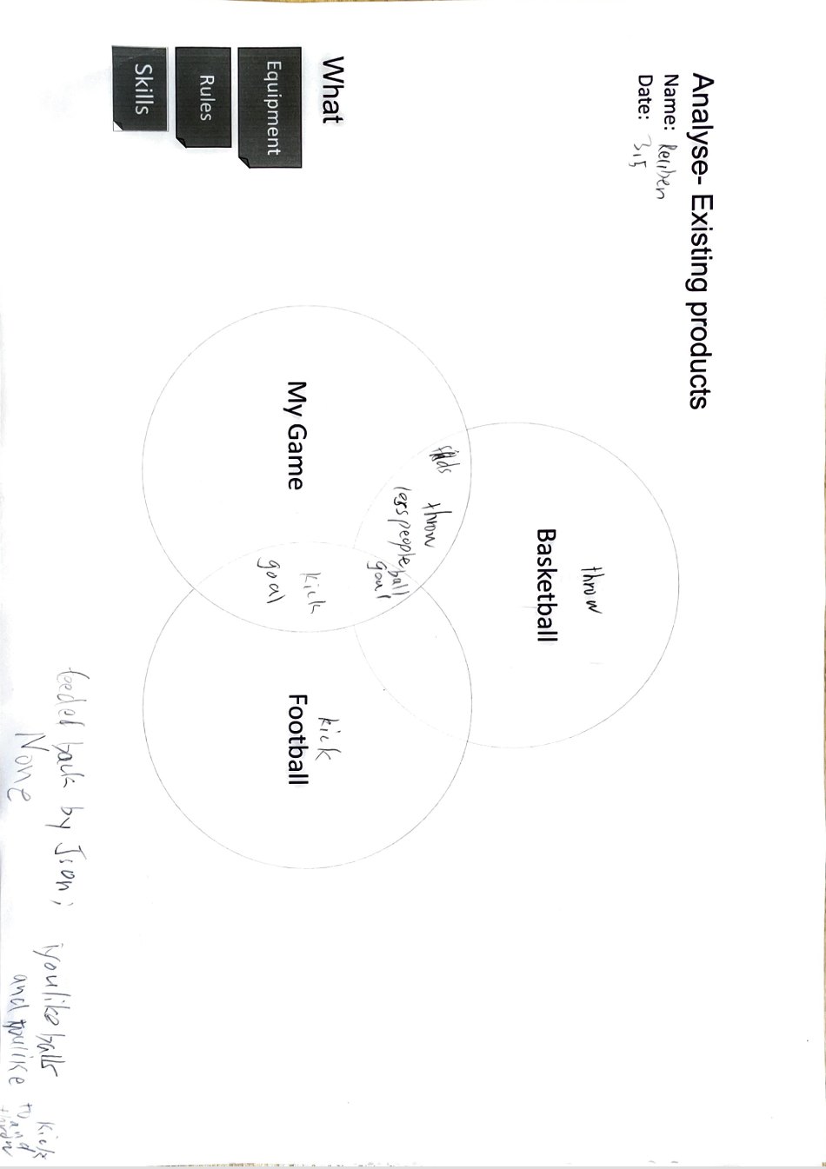

**Developing Ideas**

**After researching and doing survey,I got the information that I needed for prepare to start making games.And now,I can work on the ideas of games,which is to start thinking the games that I’m going to make.I created 3 ideas,or 3 games using the information upon.**

**Idea 1:**

**It was a bit mess,but I used many time to finish it.The brief rule is to dribble the ball into the goal using football,and goal outside the rectangular box is 3 points inside is 2 points,8 points win. NO hurting others but touching is allowed. (kick/bounce)**

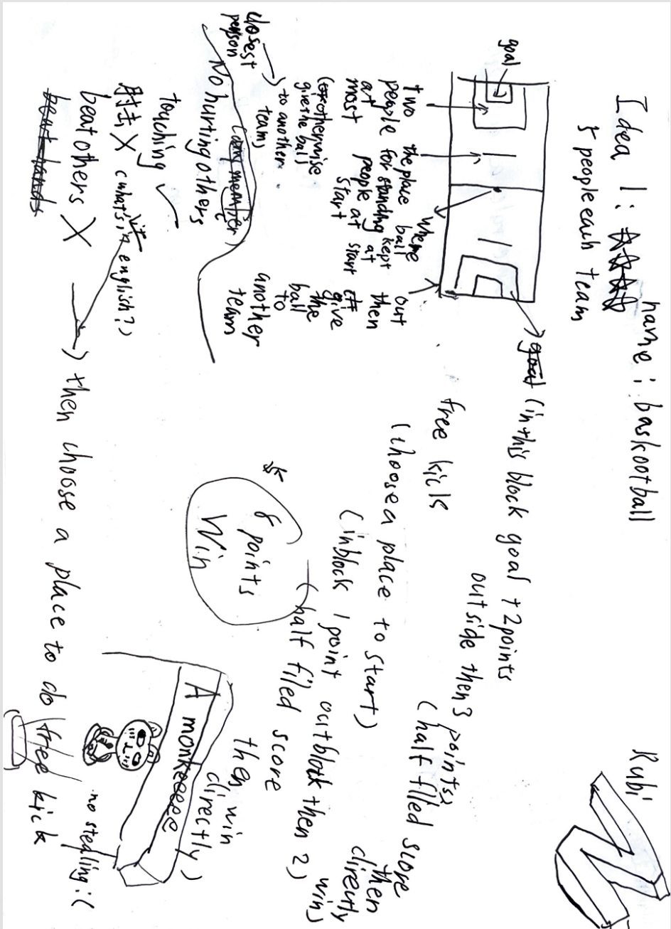

**Idea 2:**

**My second idea is a simple dodging game called the Kodge ball.It was about kicking and dodging the ball similar to the game dodge ball.(don’t mind the drawings around)**

**Idea 3:**

**My last idea is a simple throwing game called the Monkey Throw.All you have to do is to pass the ball to your teammates for 1 minutes.(each people can only hold the ball for 5 seconds and you cannot pass the ball directly touching)**

**I wrote the 2 ideas together on the picture below with specific rules:**

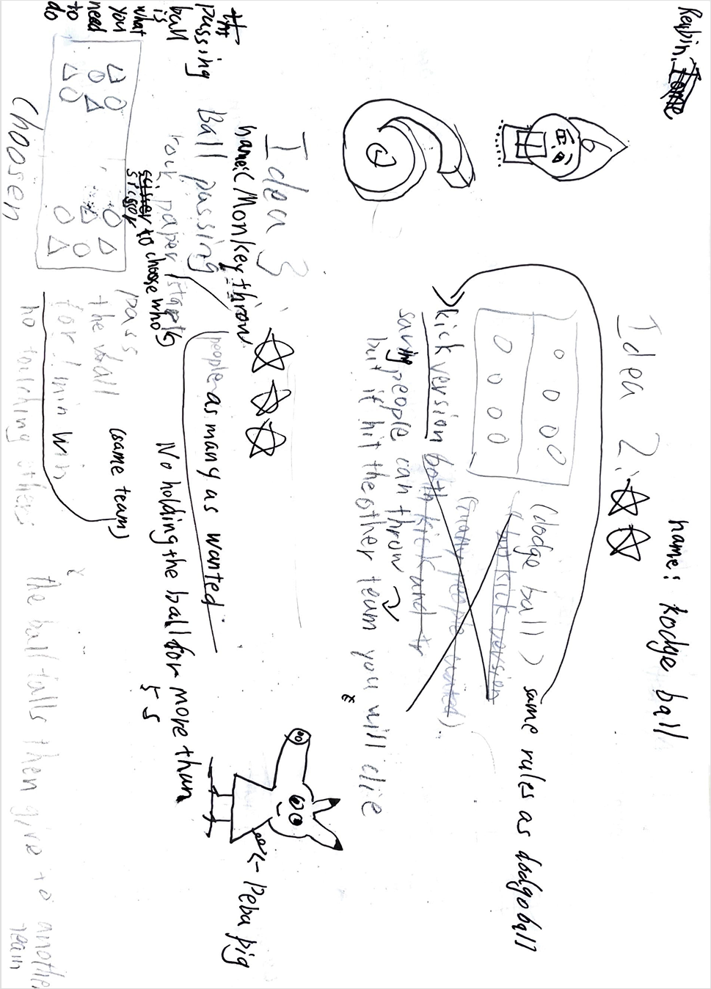

**Creating the solution**

**Because we have 12 games in our group(3 games each,4peple),so we have to choose the final one to present.First , we chose the best idea between 3 of them,and then we introduce our game.At last, we voted for the game we wanted to have for final.**

**Result for voting**

**Below is the final vote for the game,”*”represents for a vote.**

**Soren: \*\***

**Reuben:\***

**Arya:\***

**Jason:**

**According to the points,our group will do Soren’s game, and we improved it.** 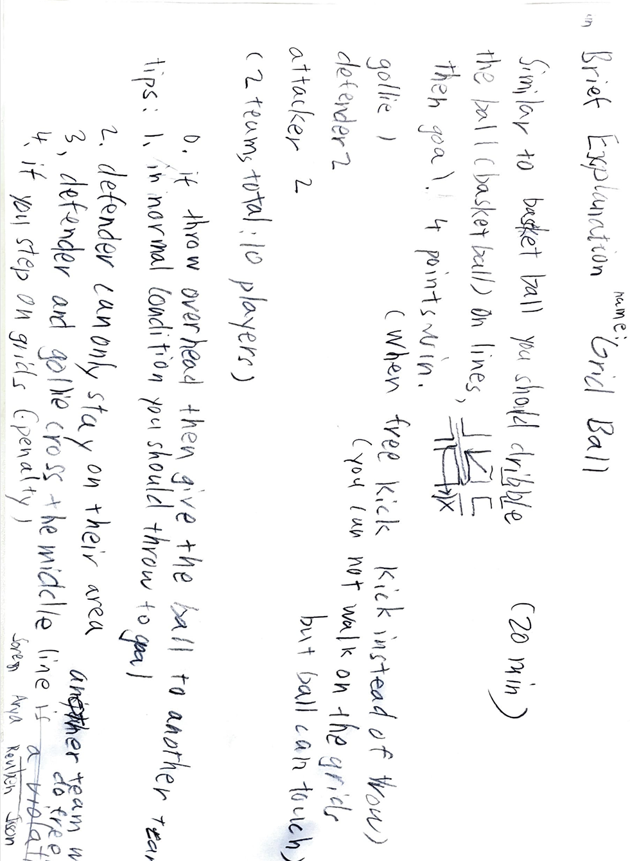

**Here is a brief explanation of the game(Soren’s), it’s similar to basketball, but you should walk on crossed lines as shown in the picture, dribble the ball and score. 20 minutes, and it includes a goalie, two defenders and two attackers. The followed pictures are also the rules and explanations of this game:**

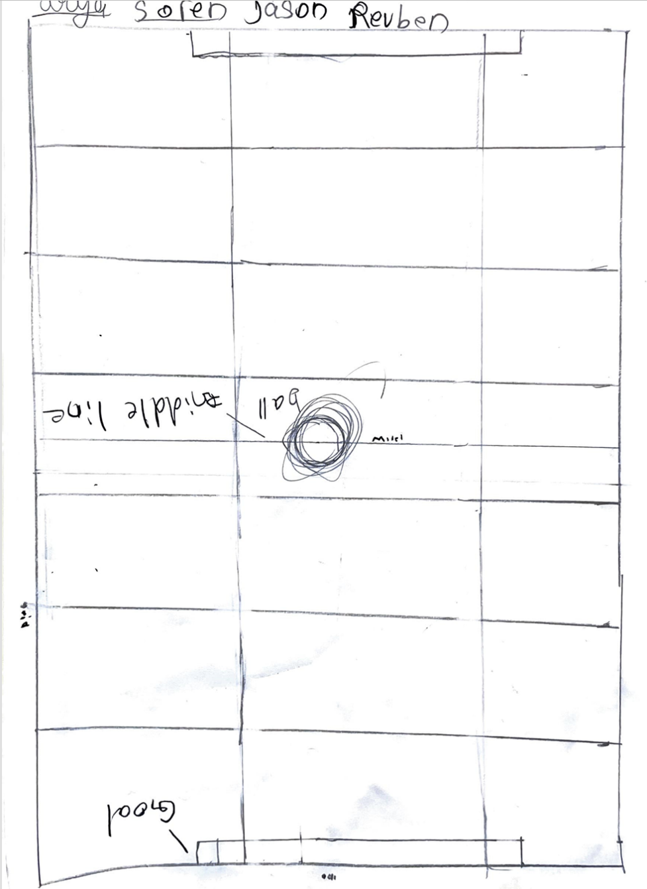

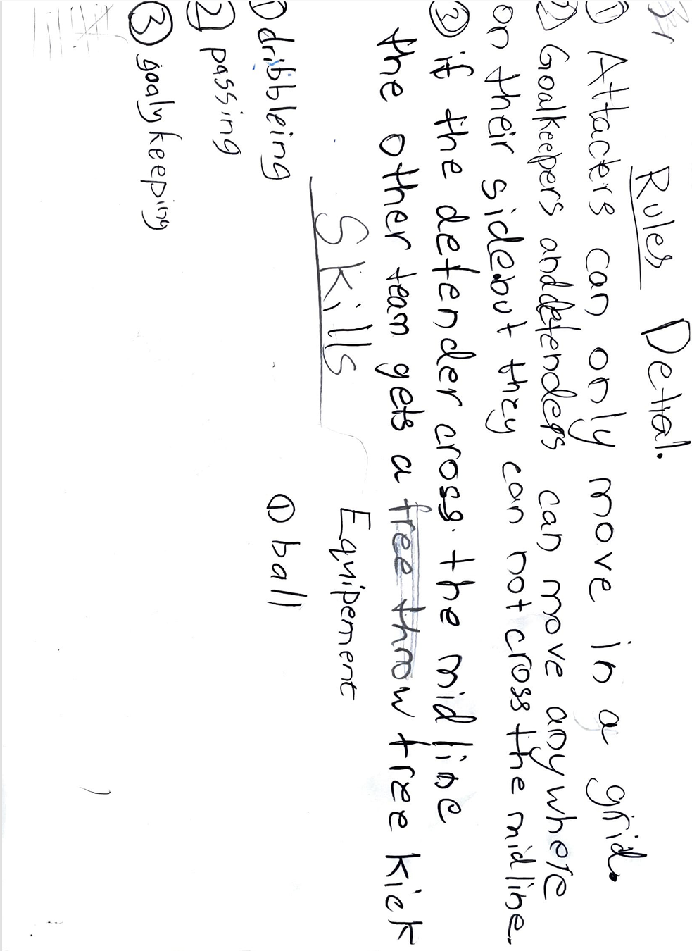

**During the game**

**On a PE class,we went outside and do our game.We introduced the game and the rules,and we are referees of this game.The game was successfully good and fun, which made us proud and happy.™™™™™™™™™™™™™™™™™™™™™™™™™™™™™™™™™™™™™™™™™™™**

**Evaluating**

**Now we are on the last unit in this assessment,we will have reflections on our game and think of the improvements we can make.**

**Disadvantages of the game**

**After the game , I thought of some disadvantages we had:**

1. **The game rules is not clear enough, so some people did not understand them.**
2. **The path for walking is too small, people will easily step out of the lines.**
3. **The place was too small and there were too many people participating.**

**Improvements could make on the game**

**For each problems,here are the possible solutions:**

1. **Make the game rule clear and make sure everyone is listening.**
2. **Find a better place to do the game which has wider lines.**
3. **Find a bigger place and split people into 3 groups to play in turn.**

**Conclusions**

**The game is fine though there are some problems, and it was successful. Everyone had had fun with it, the assessment will be ended here and it was an impressive and fun Grasps assessment.**