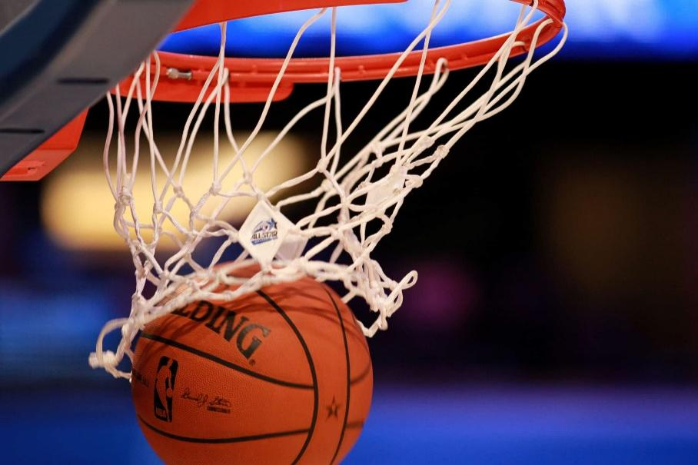Design

New

Games

Combine

Basketball

And 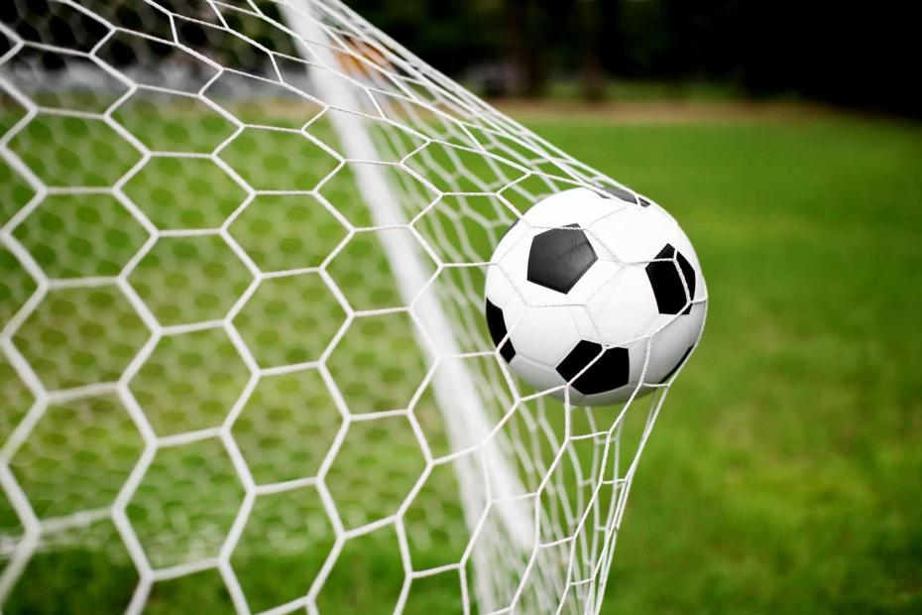Football

TABLE OF CONTENT

|  |  |
| --- | --- |
| Content | Page |
| Criterion A: Inquiring and Analyzing | 3-5 |
| Explain and Justify the Need | 3 |
| Identify and prioritize the research | 4 |
| The result of the survey | 5 |
| Criterion B： Developing Ideas | 6-10 |
| Develop a design specification | 6 |
| Develop design Ideas | 7-9 |
| Present the chosen design | 10 |
| Criterion C：Creating the solution | 11 |
| Construct a logical plan | 11 |
| Criterion D: Evaluating | 12 |
| Evaluate the success of the solution | 12 |
| Explain how the solution could be improved | 12 |
| Conclusion | 12 |

Criterion A: Inquiring and Analyzing

Explain and Justify the Need

In the sports realm, basketball wins fans over with rapid offense - defense shifts and precise shooting. Soccer gains global popularity for its vast playing field and intense rivalries. Dodgeball offers a distinctive thrill through nimble dodging and bold throws. Merging these three sports to design a new game not only creates novel gameplay, enriches the sports experience, but also propels the development of sports culture. This integration breaks the monotony of traditional sports, delivering a more thrilling experience. Basketball emphasizes hand - ball control and shooting, soccer focuses on foot - dribbling and goal - scoring, and dodgeball centers around dodging and throwing. During gameplay, players must coordinate hands and feet, adroitly switching skills. For example, they dribble the ball to a set area following soccer rules, then switch to basketball - style shooting. When facing dodgeball attacks, they dodge promptly. The combination of multiple skills enriches the game, providing enjoyment far beyond that of single - sport games.

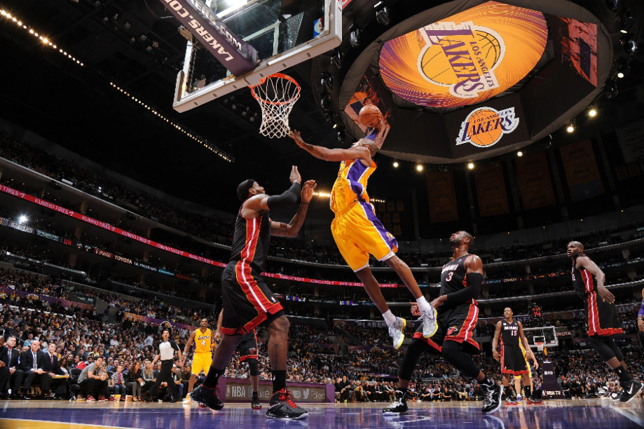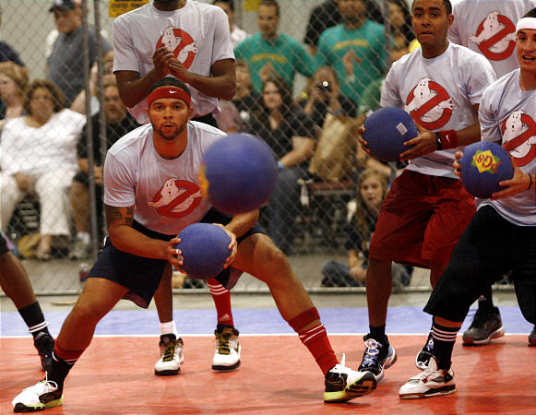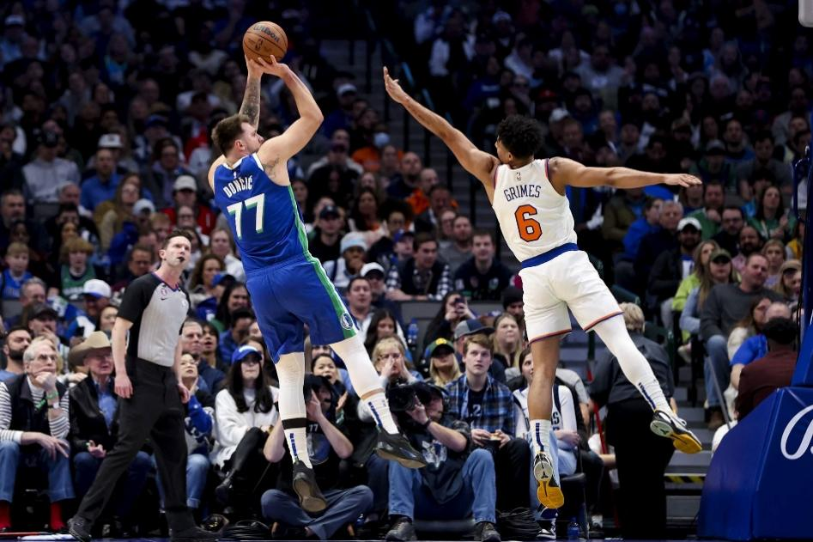

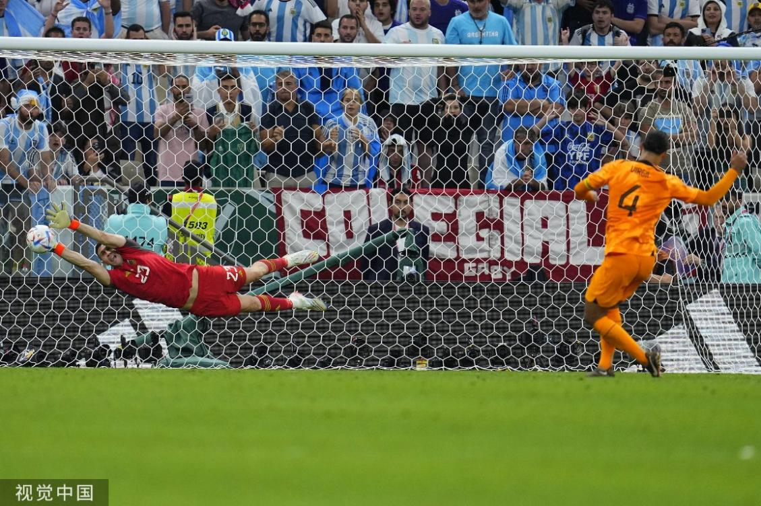

|  |  |  |
| --- | --- | --- |
| Research Area | Description | Priority Level |
| Safety  factors | Analyze the potential safety risks in the game. For example, getting injured from being hit by a ball, tripping over a hula hoop, and colliding with others while evading dodgeballs. | High |
| Player  experience | Survey the expectations and acceptance of players of different ages and athletic levels for the game, and study methods to enhance the game's fun, challenge, and fairness. | Medium |
| Venue  and  Equipment | Design the specifications and layout of the venue suitable for the new game, and develop suitable equipment, such as balls with appropriate size and function. | Medium |
| Game Rules  and  Mechanisms | Research on how to integrate the rules of the three sports, covering aspects like the scoring system and the timing for introducing dodgeball, etc. | Medium |

  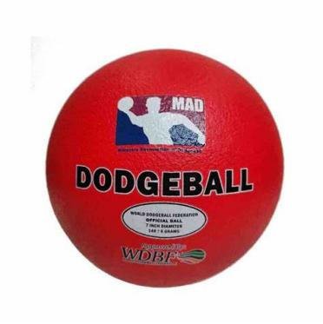

The result of the survey

|  |  |
| --- | --- |
|  | Number of students |
| Who like playing basketball | 2 |
| Who like playing football | 4 |
| Who is good at basketball | 2 |
| Who is good at football | 2 |
| Who likes using feet to play | 1 |
| Who likes using feet and hands to play | 5 |
| Who thinks basketball is harder | 3 |
| Who thinks football is harder | 1 |

Two students want 6 people in a team.

One student wants >10 people in a team.

One student wants 11 people in a team.

One student wants <8 people in a team.

One student wants 5 people in a team.

Criterion B: Developing Ideas

Develop a design specification

Audience

|  |  |
| --- | --- |
| Specification | Possible Ways of Execution |
| MYP students, Mr. Ben and Mr. Gary | In PHE class |

Functionality

|  |  |
| --- | --- |
| Specification | Possible Ways of Execution |
| Entertainment, stimulate creativity | Search some information |

Develop design Ideas

Design 1:

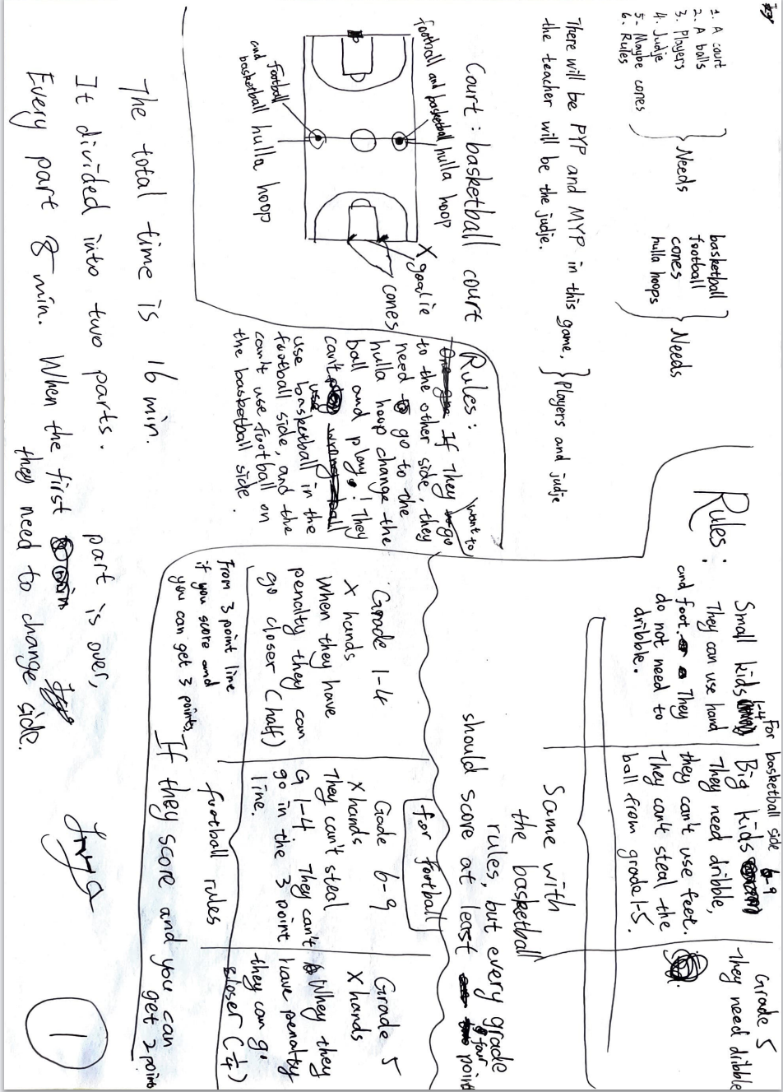

Design 2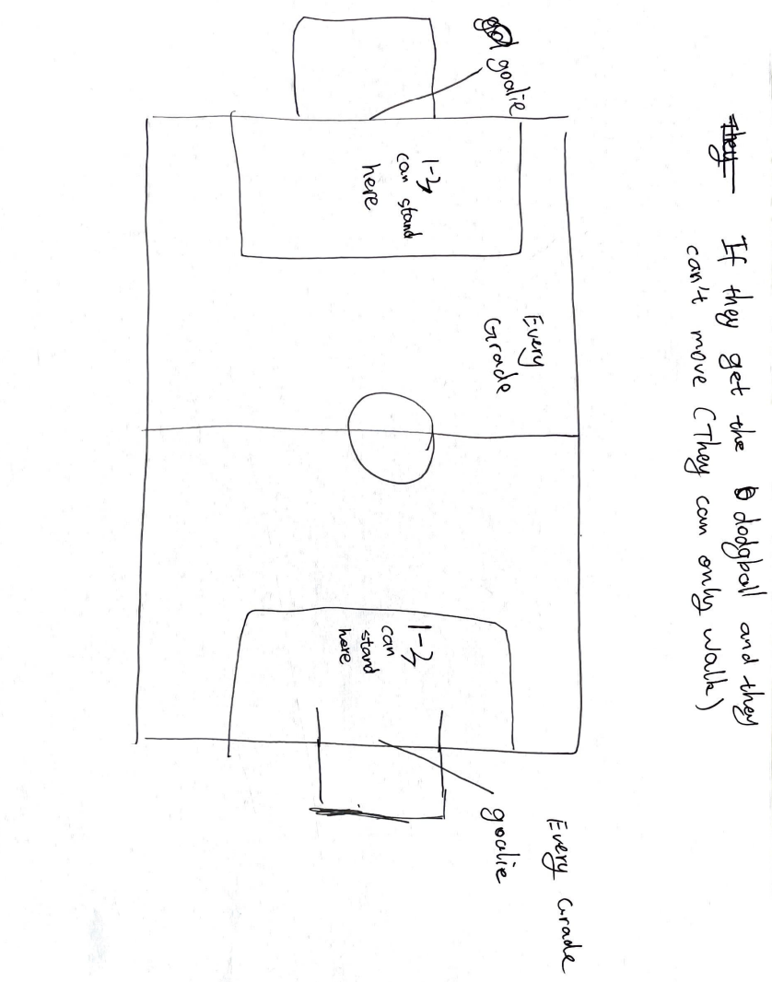

Design 3:

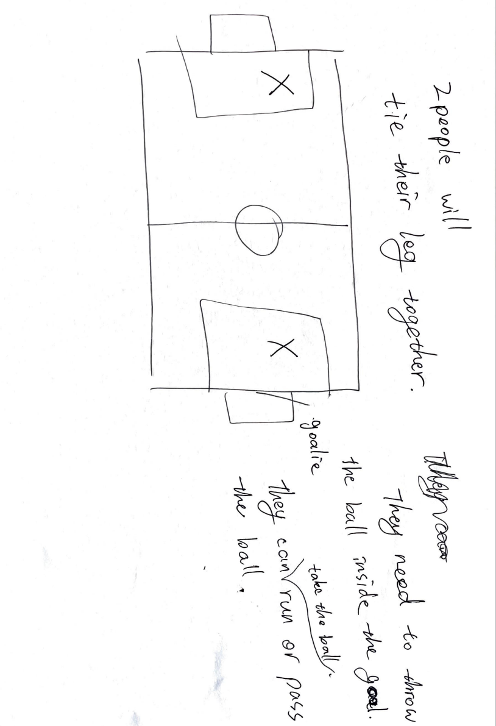

Present the chosen design

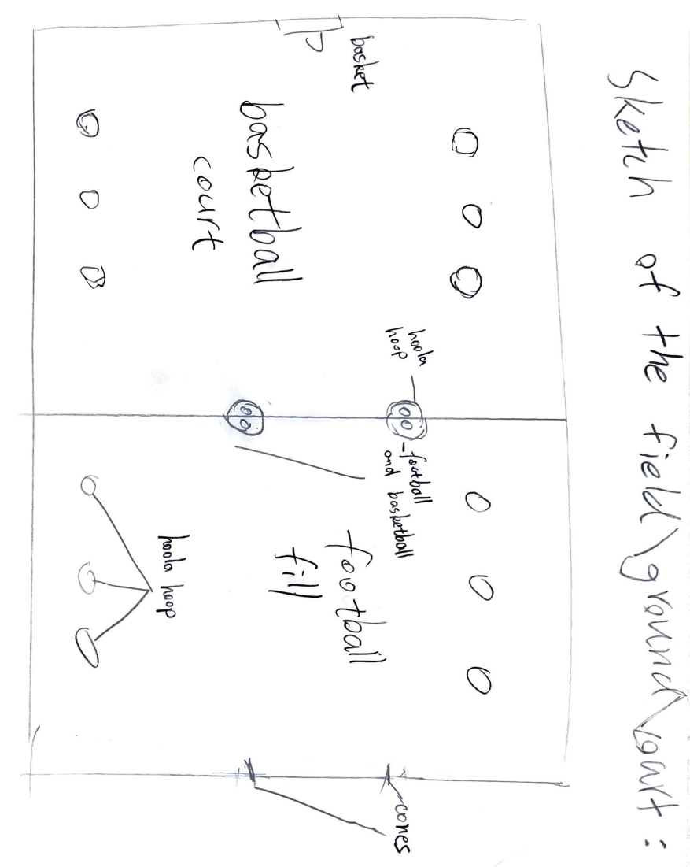

Rules:

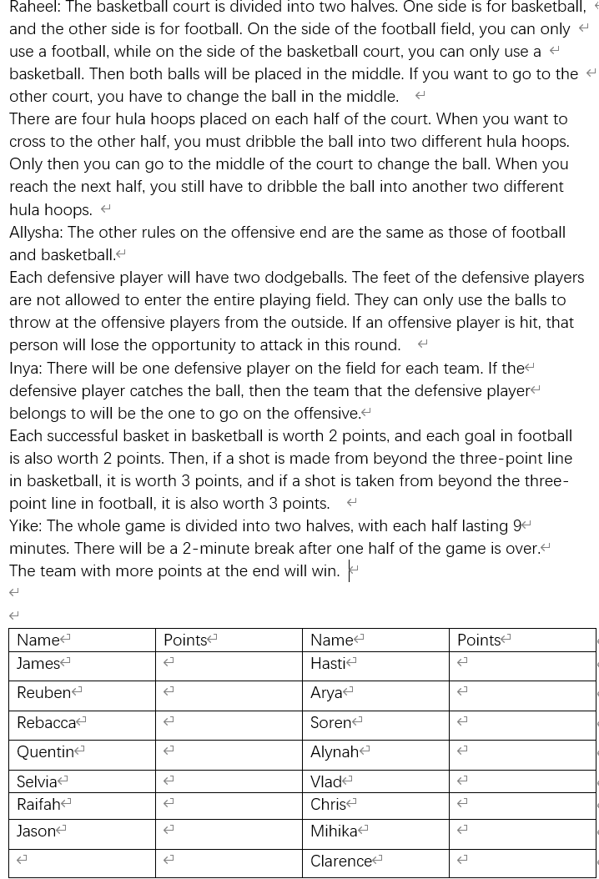

Criterion C：Creating the solution

Construct a logical plan

|  |  |  |
| --- | --- | --- |
| Step No. | Aspects to be accomplished | Time required |
| 1 | Finish the rules | 1 hour |
| 2 | Divide the team | 10 min. |
| 3 | Confirm the property | 5 min. |
| 4 | Print the rules and the team number | 5 min. |

Criterion D: Evaluating

Evaluate the success of the solution

If there are 10 points, I will give 2.

I think our game is very creative.

But I think the rules are a little bit difficult and complex to the players. And there are so many properties.

No one understand our rules.

Explain how the solution could be improved

1. Make the rules simpler.
2. Use less property.

Conclusion

I really enjoyed the process of creating this game. I think our game is very creative, and we also put in a lot of effort during the creation. Although our game turned out to be a failure, I'm not discouraged. I believe we will do much better next time.