By

Arya Gupta

Grade 6, WUIS

A portfolio on Grid Ball: The Ultimate Sport

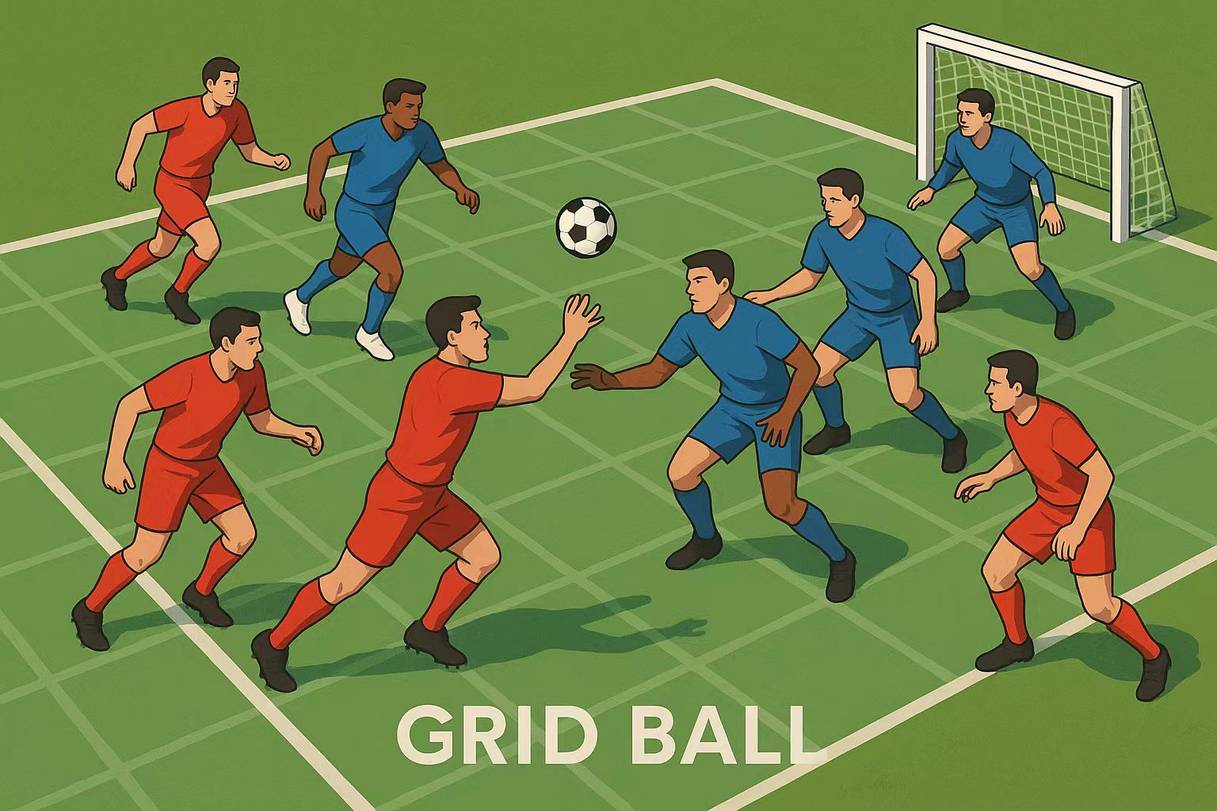

Introduction

**Why Grid Ball?**

We wanted a fast-paced game mixing strategy and teamwork.

A mix of soccer, basketball, and chess—but totally unique!

**Inquiring and analyzing:**

We made the Venn diagram to know what equipment, rules and skills are the similarities between my game, football and basketball.

**Venn diagram**

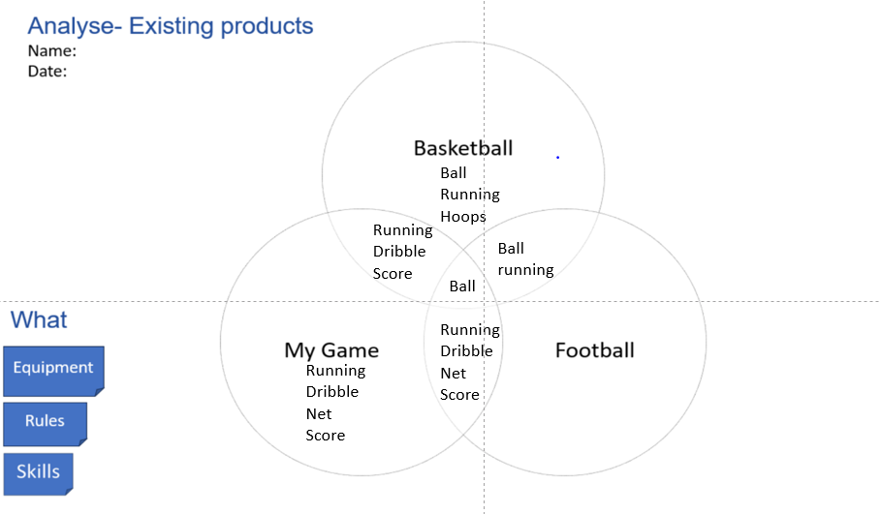

**Questionnaire: Gathering Ideas for Grid Ball**

**(Based on my Venn Diagram Research)**

To design Grid Ball, I surveyed other students to learn what they enjoy about basketball and football (soccer). This helped me mix the best parts of both sports into my new game!

**Survey Questions**

1.Do you like sports?  
2.What do you like about basketball?  
3.What do you like about football?  
4.Do you like basketball?  
5.Do you like football?  
6.Are you good at running?  
7.Are you good at shooting the ball in basketball?  
8.Are you good at kicking the ball in football?  
9.Are you good at dribbling the ball in football?  
10.Are you good at dribbling the ball in basketball?

Results

|  |  |  |  |  |  |  |  |  |  |  |
| --- | --- | --- | --- | --- | --- | --- | --- | --- | --- | --- |
| students | 1 | 2 | 3 | 4 | 5 | 6 | 7 | 8 | 9 | 10 |
| Allyssha | Yes | Teamwork | Teamwork | Yes | Yes | No | Yes | No | No | yes |
| Inya | Yes | Dribble | Shooting | Yes | Yes | Yes | Yes | Yes | Yes | Yes |
| Reuben | Yes | Score | Kicking | Yes | Yes | No | No | No | No | No |
| Raheel | Yes | Throwing | Everything | Yes | Yes | No | No | Yes | No | yes |
| Jason | Yes | Teamwork | Teamwork | Yes | Yes | Yes | Yes | Yes | Yes | Yes |
| Soren | Yes | Layups | Kicking | Yes | Yes | No | No | Yes | No | yes |

Conclusion

All 6 students (100%) like sports, basketball, and football.

What students like about basketball:

* Teamwork – 2 students (Allyssha, Jason)
* Dribbling – 1 student (Inya)
* Scoring – 1 student (Reuben)
* Throwing – 1 student (Raheel)
* Layups – 1 student (Soren)

What students like about football:

* Teamwork – 2 students (Allyssha, Jason)
* Shooting – 1 student (Inya)
* Kicking – 2 students (Reuben, Soren)
* Everything – 1 student (Raheel)

**Developing ideas:**

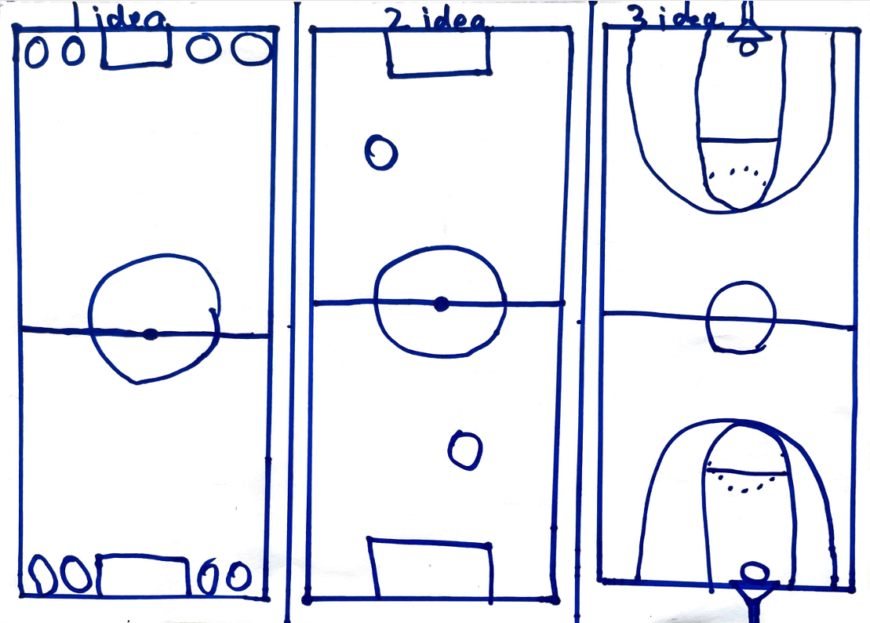

So these are my 3 ideas now I am going to give a brief explanation for these three ideas;

**Rules**

1 idea = Grade 5-9 score in the small cones.

Grade 1-4 score in the net.

The team has to pass to their teammate grade 1-4 at least 3 times.

From both teams grade 1-4 has to at least score 2 times.

No fouling, If then penalty from the penalty box.

You can only score after the midfield line.

2 idea = You cannot hold the ball and walk.

You have to dribble the ball if you are walking with it.

There is no goalkeeper

If there any foul the other team gets the ball.

In order to score you have to pass the midfield.

3 idea = You have to dribble the ball with your feet and score with your hand.

You can only dribble outside the 3 pointer line.

If there is a foul, then the other team gets a free throw.

If you made the shot in the 3 pointer line, then you get 1 point.

If you made the shot outside the 3 pointer line, then you get 3 points.

So these were the rules of these 3 ideas but I chose the first Idea.

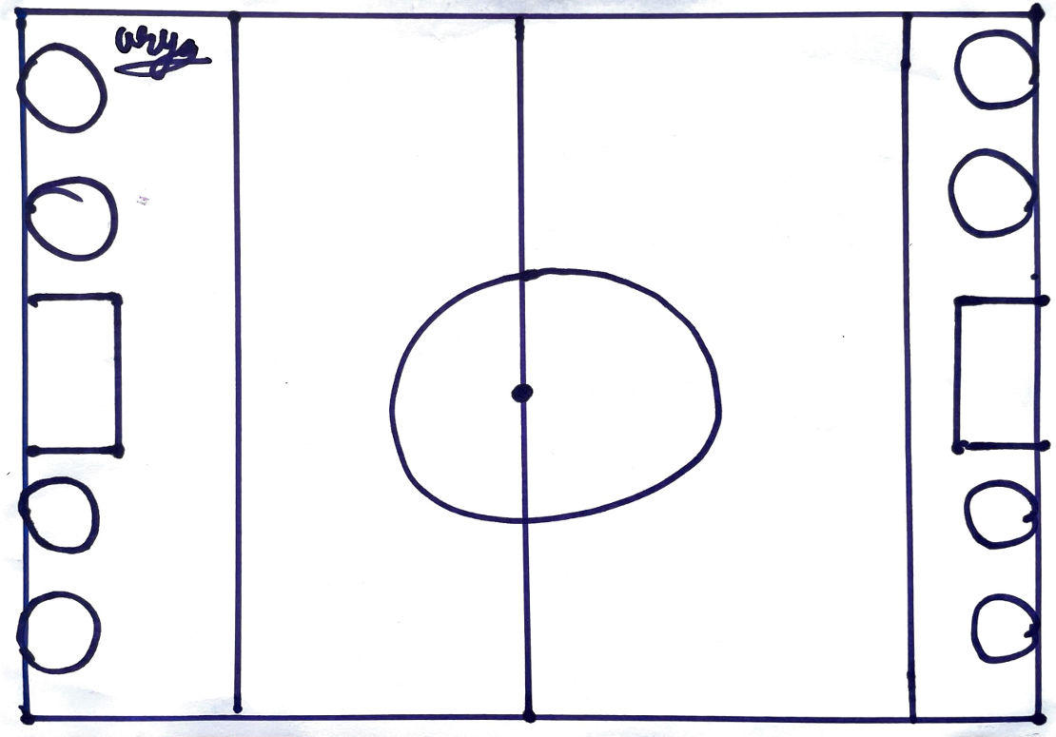

**Creating the solution;**

So we made a team and our team members are

Soren Jason Arya Reuben, and we chose Soren’s game.

We Made a WeChat group so we can discuss ideas.

This is the game rules

Field/Court

The court is a grid with squares and with narrow boundaries between each of the squares. There is a net on the left and the right of the court for scoring.

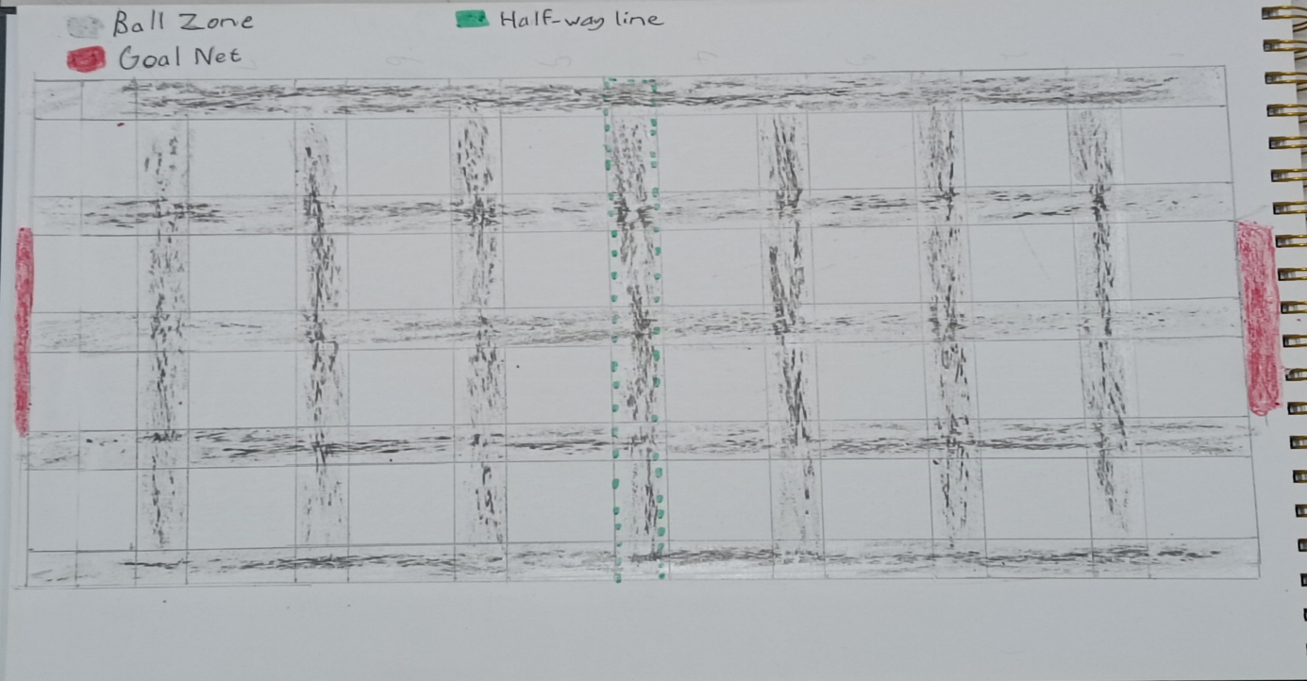

Objective

Teams must bounce a ball on the narrow boundaries called the Ball Zone so that they can score a goal by throwing the ball into the net at the opposite end. Each goal is worth 1 point. Winner is the team with the most points after 15 minutes.

Players

Two teams, each team has five members.

2 x Defenders

2 x Attackers

1 x Goal Keeper

Rules

The players can only move on the narrow boundaries (Ball Zone) between squares and cannot step into the squares. Except for the Goal Keeper.

The player with the ball can only bounce the ball within the Ball Zone (narrow boundaries).

The player can only throw the ball to another player.

If the ball lands on a square it can be picked up by any team but no one can step into the square to get it.

Attackers can only stay on the other team’s half of the court.

Defenders cannot leave their half of the court.

Goalkeepers can only move along the squares directly in front of the goal net. But they cannot step in the Ball Zone at all.

If a player steps into a square they are out of the game for five minutes. If a goalkeeper steps into the Ball Zone he is out of the game for five minutes.

**Evaluating;**

The Strengths of this game is;

Very creative and you need to do a lot of teamwork in order to score.

Players need good balance, agility, and ball control to navigate narrow zones.

The Weaknesses or Challenges of this game is;

Risk of tripping or falling unless the playing surface is very carefully designed.

The goalkeeper is confined to squares and can’t interact with the Ball Zone, which might feel boring compared to other roles.

Players stepping into squares may happen often, leading to lots of timeouts.

The Suggestions for Improvement of this game is;

Allow goalkeepers to block from within a designated safe square zone.

Allow the attackers and the defenders to have more space.