“Slam Soccer”

Raifah, 4/14/2025 IDU-Bridging Sports through Design

Design of a Basketball-Football Integrated Competitive Game

**Table of Contents**

1. Inquiring and Analyzing

1.1 Project Background

1.2 Study of Similar Sports Games

1.3 Study of Game Rules and Terminology

1.4 Identifying the Player Need

1.5 Summary of Main Findings

2. Developing Ideas

2.1 Initial Game Concepts

2.2 Inspiration Sources

2.3 Refining Game Concepts

2.4 Selecting a Chosen Design

3. Creating the Solution

3.1 Working in a Team

3.2 Dividing Roles

3.3 Preparing Materials and Game Explanation Graphics

4. Evaluating

4.1 User testing

4.2 Data Analysis

4.3 Reflection and Future Improvements

4.4 Project Summary

1. Inquiring and Analyzing

1.1 Project Background

**Statement of Inquiry**

Adaptive systems promote balanced participation and cooperative achievement in physical activities.

1.2 Study of Similar Sports Games

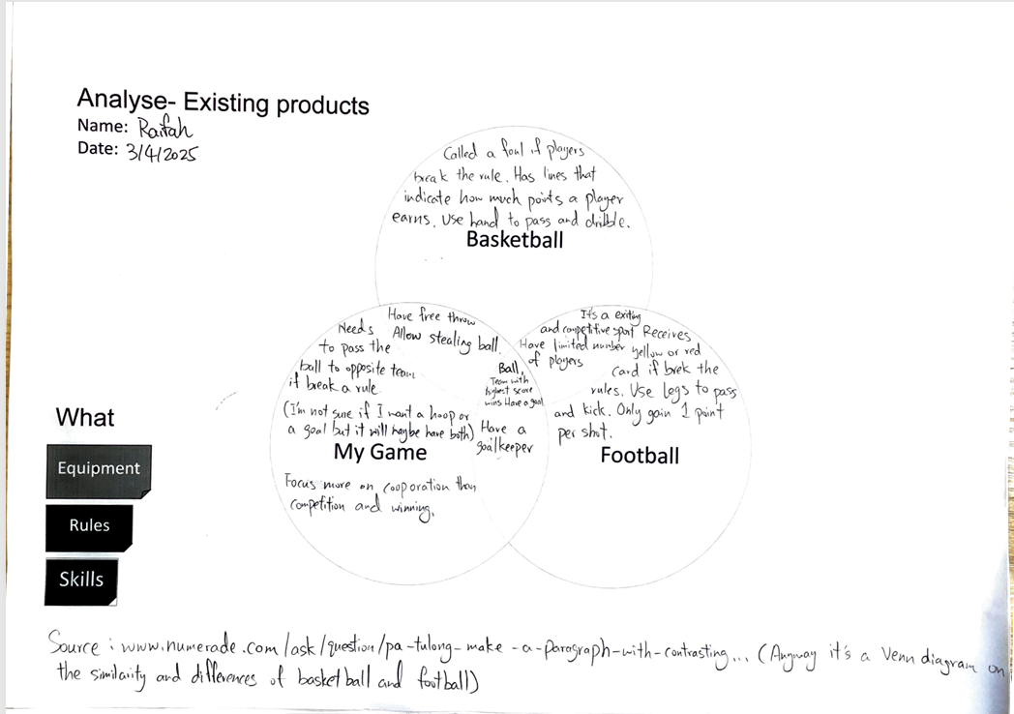

I made a Venn diagram comparing the similarities and differences of basketball, football, and potentially my game. This step was crucial for the game design since we can easily understand the main features of these sports, and chose some elements from these.

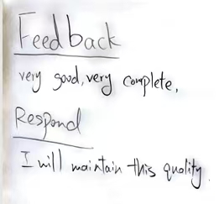

Then, I shared my ideas and we also practiced giving constructive feedbacks to each other.

1.3 Study of Game Rules and Terminology

At the same time, we had lessons with Mr. Ben about some basic information on Basketball and Football.

We learned many useful rules, equipment, fouls, violations and terminology. It was very helpful for me since it provided more information on these aspects that may be overlooked normally but are useful in game designing.

I made some notes during class. And what did I do on the rest of the classes? The teacher showed us some videos about some injuries and silly fouls committed. The injuries raised awareness and made me think more about safety. The fouls made me understand that sometimes miscalculations can happen, and although football and basketball are two well-developed games, these problems can still occur. So it’s important for the game designer/me to consider the complexity and clarity of game rules.

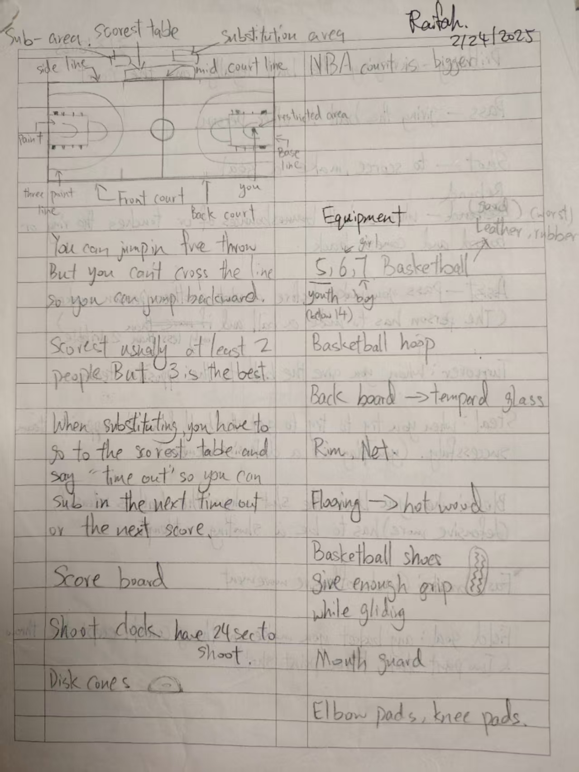 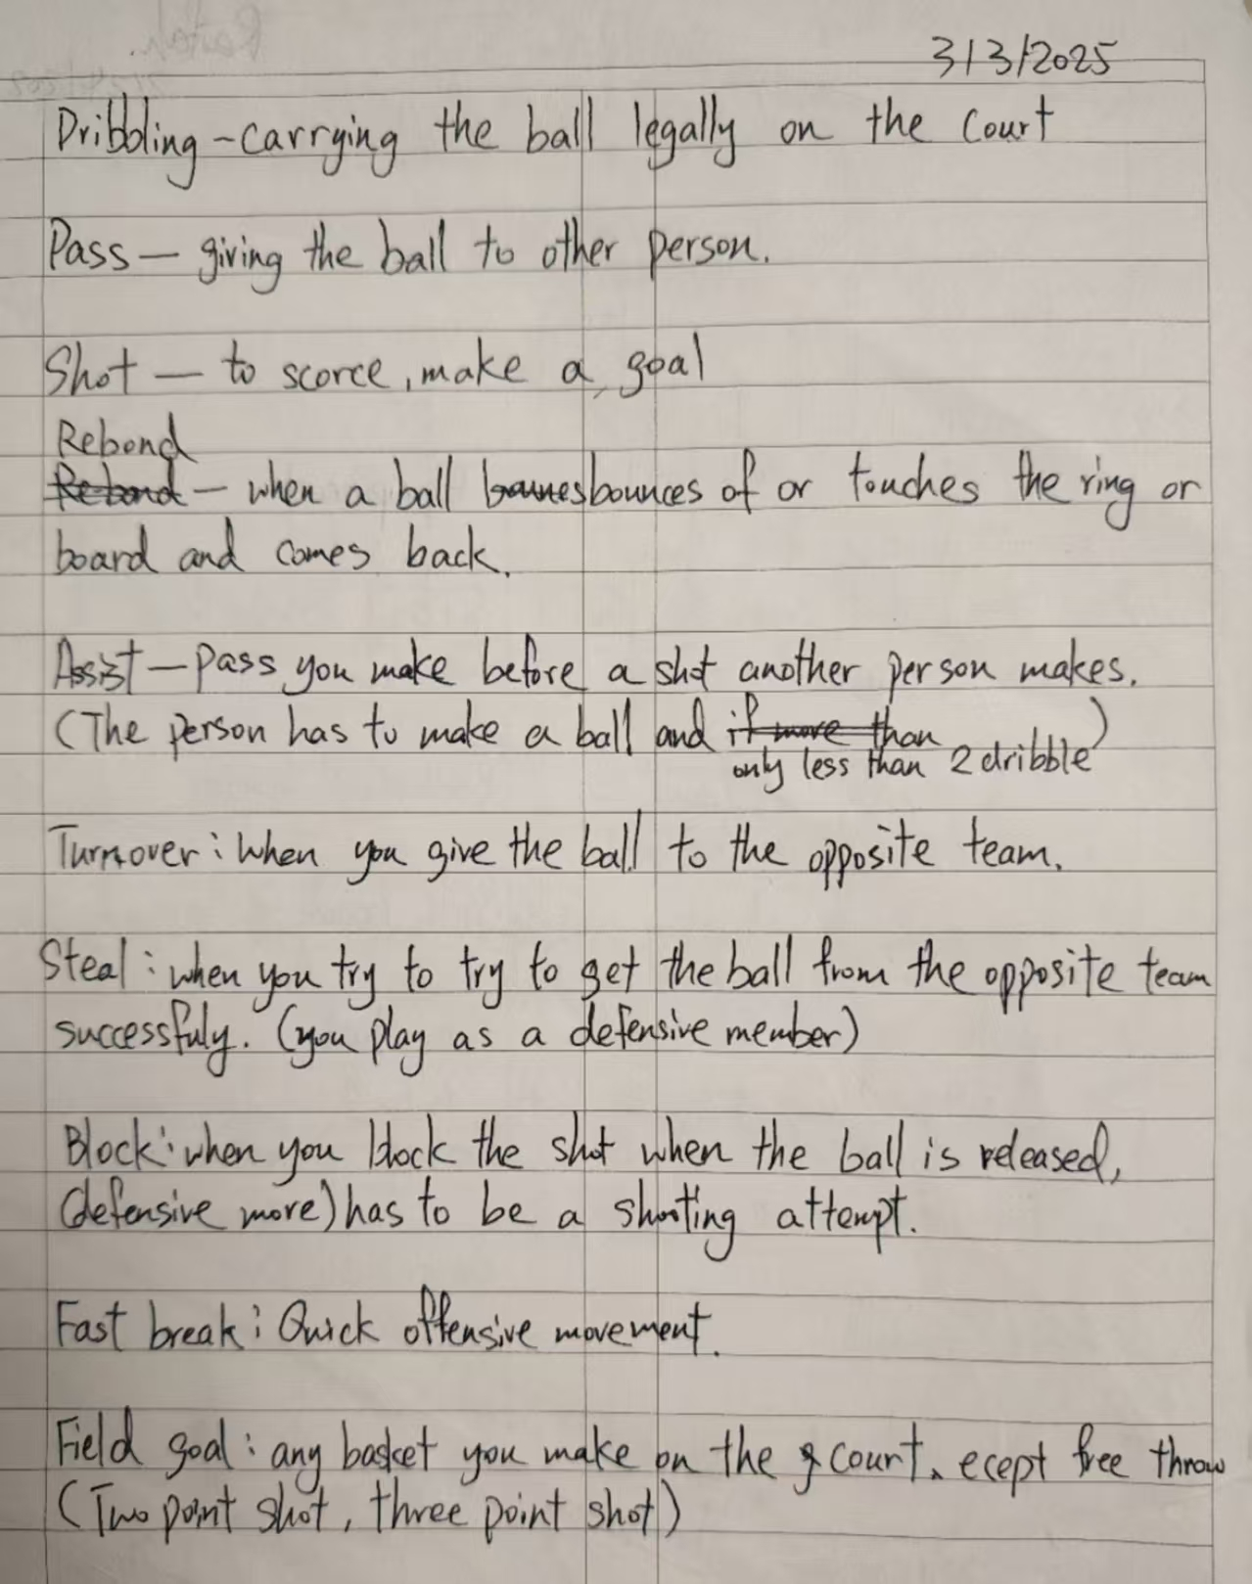 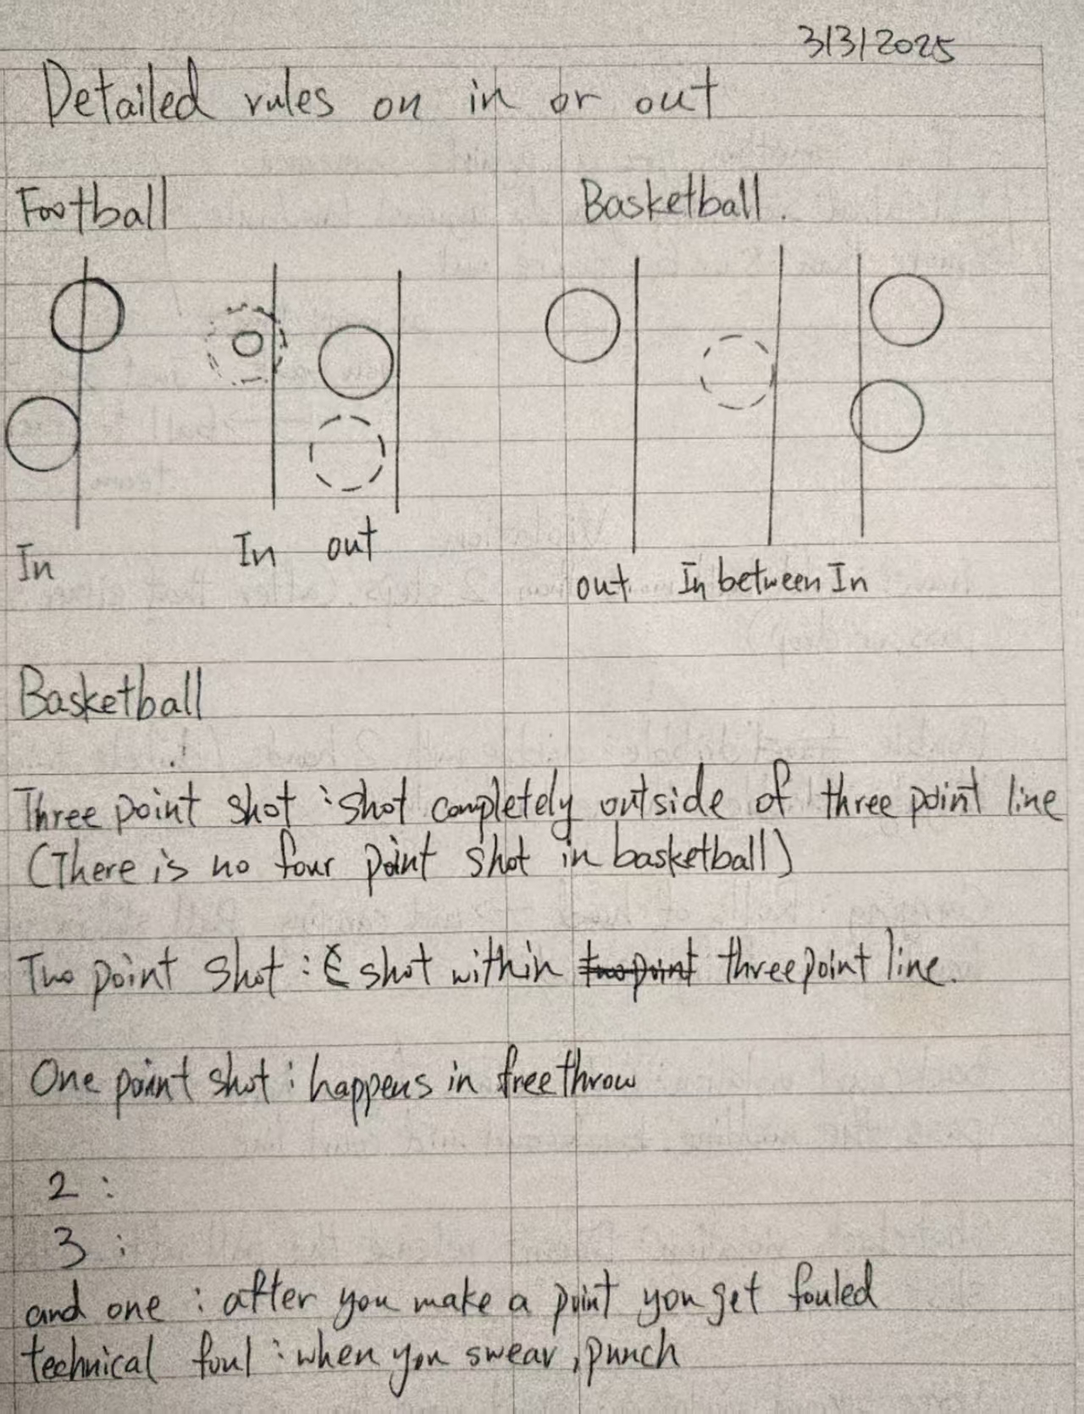 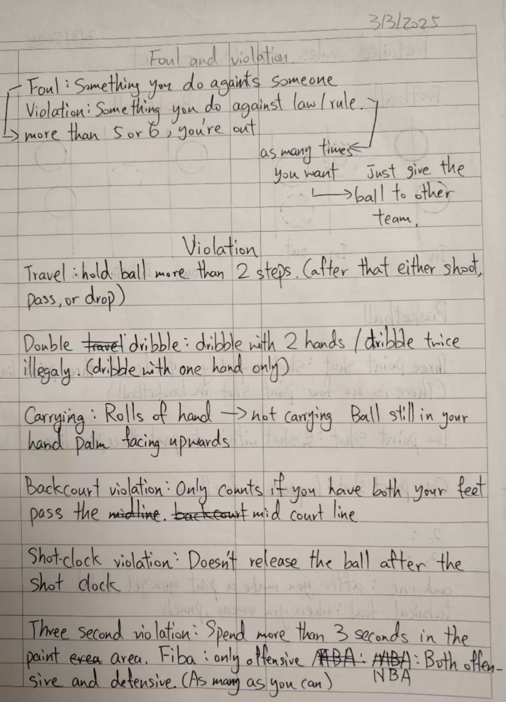 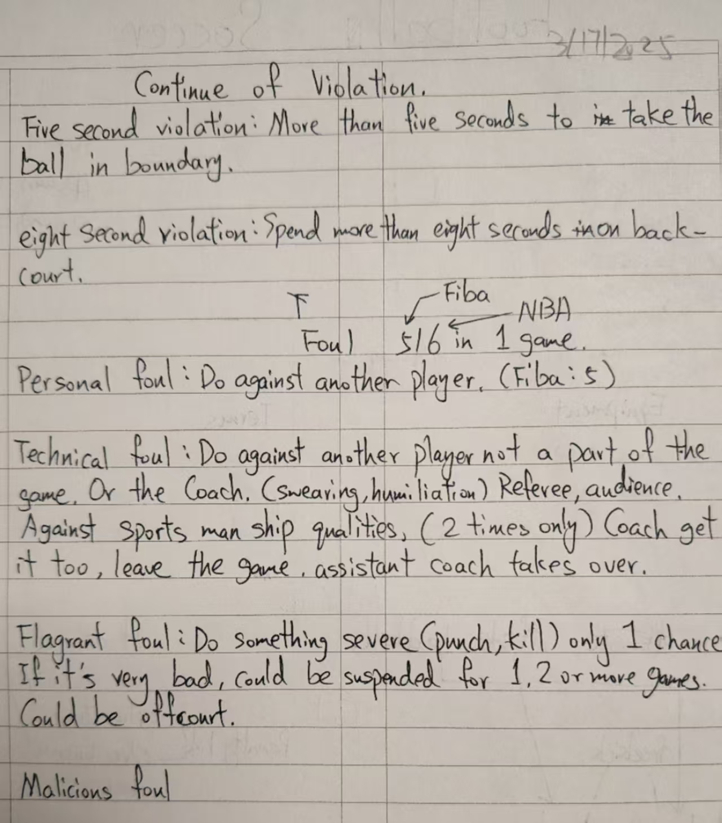 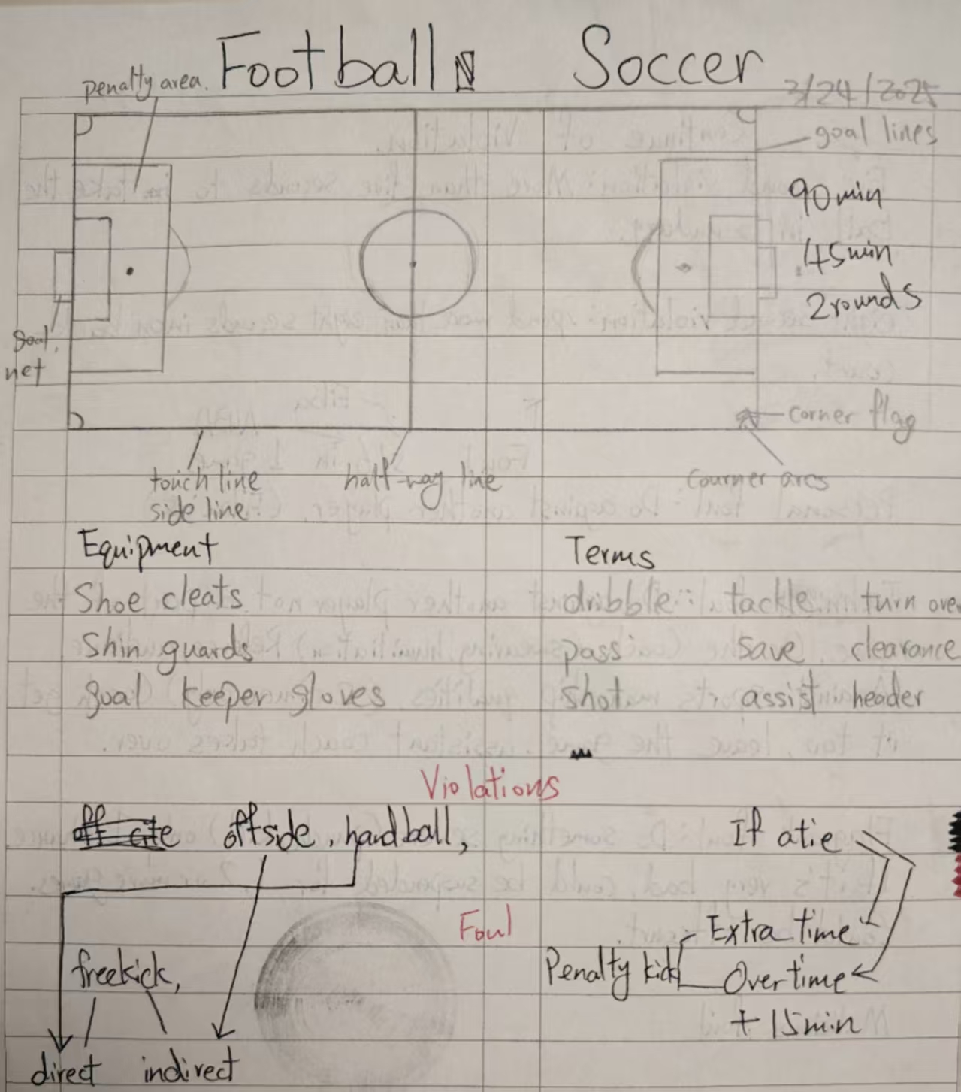

Adn

1.4 Identifying the Player Need

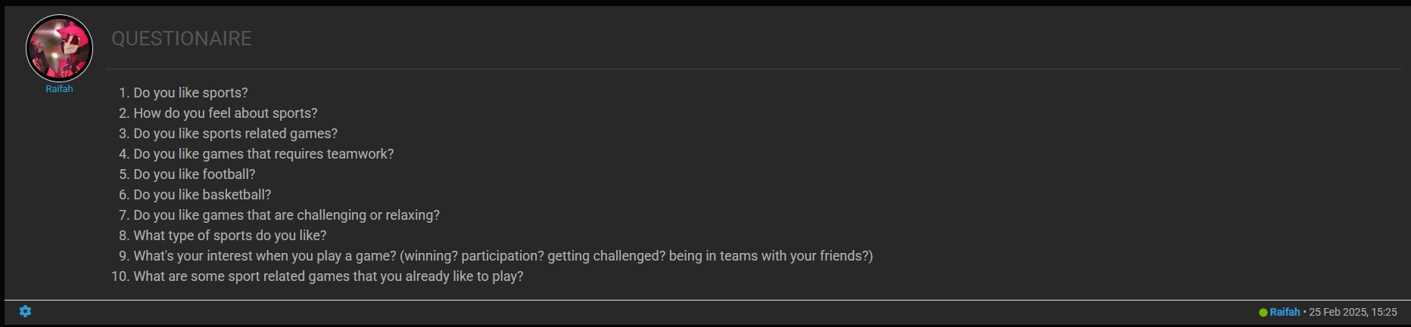

* I did a questionnaire that investigates the interests of players. This helps me in making the game more suitable for personal interests. After collecting the data, I made a table to present it.

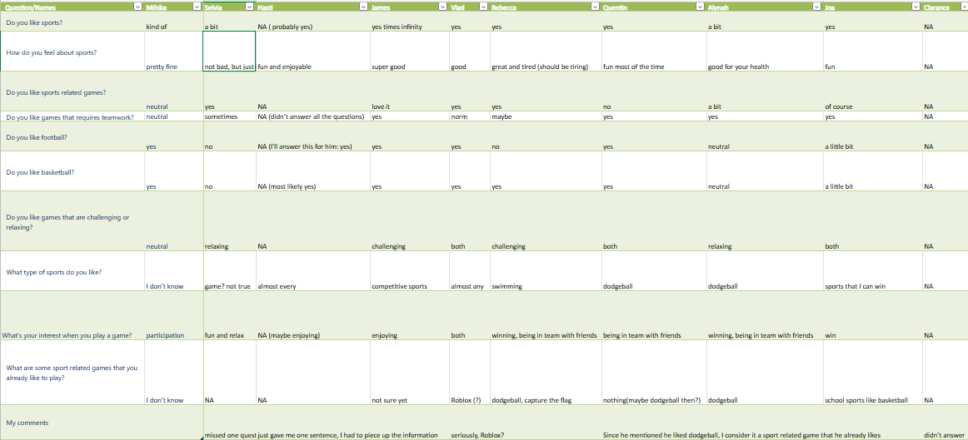

(This table is not fully presented)

<https://community.wuis.net/assets/uploads/files/1740907625338-0e21d67e-785f-4186-bcec-68efc70254e5-data-collected-from-the-questionaire.xlsx>

1.5 Summary of Main Findings

After reviewing and collecting the data form the questionnaire, here are some of my findings:

1. General Attitude towards sports

- Most respondents have a positive or neutral attitude towards sports. For example, responses like “yes”, “a bit”, and “pretty fine” indicates some level of interest in sports. However, there are a few “NA” values, such as in the case of Clarence.

2. Feelings about sports

- Everyone who answered had a mainly positive feeling towards sports, with descriptions like “super good”, “good for your health”, and “fun most of the time”. This shows that respondents associate sports with positive experiences.

3. Preferences for sports - related games

- There is a mix of responses. Some like sports - related games (“yes”, “love it”), while others are neutral or have not given a clear answer. For team - work - required games, the answers also vary, with some saying “yes” and some being neutral or having incomplete responses.

4. Football or Basketball

There is a minority of people that don’t like football or basketball or both, but compared to basketball there are more people who dislike football. But participants mainly like football and basketball.

5. Specific sports preferences

- Regarding football and basketball, opinions are divided. For other types of sports, responses range from “almost every” competitive sport to specific ones like swimming and dodge ball.

6. Interests when playing games

- Many respondents value participation, having fun, relaxing, and being in a team with friends. Winning is also an important factor for some.

7. Favorite sports - related games to play

- Dodge ball seems to be a popular choice among those who provided answers. Some also mentioned school - based sports like basketball and online games like Roblox.

2. Developing Ideas

2.1 Initial Game Concepts

Now that some research is done, it’s time to move on to designing the game.

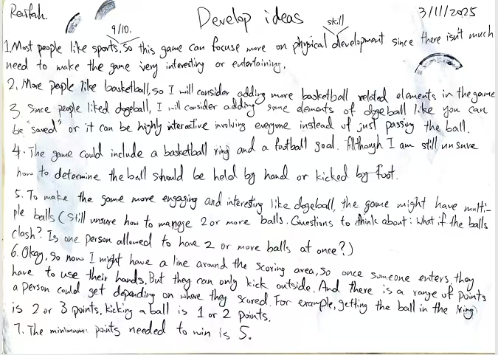

I initially had a brainstorm and listed out some of my ideas.

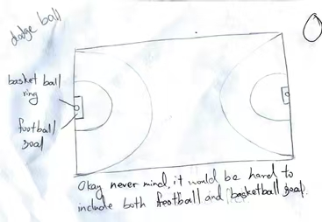I also made a sketch of what the game could look like.

2.2 Inspiration Sources

I had a barrel of ideas that I needed to sort out with. First, I had the initial idea in the Venn diagram that I was going to include two goals on each side in my game. I was not very certain about it yet since there were some challenges in combining both football and basketball goal. But after thinking about it, and considering it could be one of my main appeals, I decided to incorporate it. So the idea of a hand-ball zone got refined and I thought of specific, detailed situations. There was another idea that popped up at the last moment; it was to add punishment/ quiz cards after the game is finished. My team and I thought of some punishments, and at last, I kept some quiz related to Mr. Ben’s class as a cherry on top. I thought it would be nice if we had a little revision of what we had learned in his class too.

2.3 Refining Game Concepts

As I reflect on my thoughts, I started refining my ideas.

Here are a few Ideas I came up with the help of some previous ones, some inspiration and compiling them.

1. Since most people like sports (9/10), the game can emphasize physical development rather than focusing too much on entertainment.

2. Given the popularity of basketball, more basketball - related elements will be considered for inclusion. The appeal of dodge ball is also recognized, with plans to incorporate some interactive features from it, like getting "saved" concept and more inclusive gameplay instead of just ball passing.

3. There were initial thoughts of including both a basketball ring and a football goal in the game, but there were uncertainties about when to use hands or feet to handle the ball. The idea of using multiple balls to increase engagement, similar to dodge ball, was proposed, along with questions about ball management, such as what to do if balls clash and whether a player can hold multiple balls at once.

4. A potential rule considered is having a line around the scoring area where players must use their hands inside and can only kick outside. Different point values were suggested depending on how and where the ball is scored (e.g., 2 or 3 points for getting the ball in the ring, 1 or 2 points for kicking a ball).

5. The minimum number of points needed to win the game is set at 5.

6. A person cannot have 2 balls at the same time.

7. There is a goal keeper for the football goal.

8. When 2 balls clash, the game usually continues normally. However, if one of the ball gets pushed out of boundary, the team responsible for kicking it out hands the ball over to the opposite team. For example, if team Red’s ball hits team Blue’s ball and it goes out of boundary, team Blue still gets the ball. For rare cases when both balls clash and gets out of boundary, here are a few ways to deal with it. First, the referee will carefully review the play. If it’s clear that one team’s player made a kick that directly caused both balls to go out, that team losses possession of both balls. Then, the team that gains possession should quickly retrieve the balls. If the balls are retrieved from the basketball only zone, they can be thrown back into game by hand, if retrieved from outside that zone; they can be either thrown in by hand or kicked back in. For unclear cases, a jump ball could be arranged. To avoid long pauses in the game, an extra ball can be introduced. (I am going into too much detail here, but these questions needed to be solved: D)

9. When the ball gets kicked in the basketball only zone and goes out of bond, the goal keeper on that side could throw the ball back in (he/she has the choice of throwing it in the basketball only or the football zone)

10. Bonus points could be added when teams score continuously. (1 point)

11. Bonus points could be added when the goal keeper and one of their teammates switch place any ball blocked during this process could add an extra point to the team. (One player can only block the ball in replacement of the goal keeper; first swamp will start when at least 5 points are made by either team. The team have the choice to do it or not.) This can make the game more interesting and give opportunities for players to develop different skills and take risks.

12. There could be power-ups if the team scores very fast after they gain possession.

2.4 Selecting a Chosen Design

As I continue reflecting and refining on my thoughts, looking back to all the research I did, I chose one design.

1. Design Brief

The designed sport is a unique hybrid of basketball and football, aiming to combine the best elements of both sports to create an exciting and engaging new game. It uses a playing field with a basketball hoop and a soccer goal at each end, a designated handball zone, and the use of two balls simultaneously. The game's objective is for teams to score 15 points, with a requirement of at least three basketball goals and football goals. Points are awarded based on scoring in the hoop or goal, and there are bonus points for consecutive shots.

2. Considerations for Selection

Game Complexity

- The combination of basketball and football elements offers a rich and complex gameplay experience. The use of two balls adds an extra layer of strategy, as players need to manage ball possession, passing, and shooting while being aware of both ball’s movements. However, it also increases the risk of confusion and safety hazards. After careful consideration, this complexity is seen as an asset as it can keep players engaged and challenged.

Scoring System

- The scoring system, which includes different point values for basketball hoops and soccer goals and bonus points for continuous scores, encourages diverse playing styles. It promotes both long range shooting in basketball and strategic goal scoring in soccer. The requirement of a certain number of basketball goals ensures that players can't rely solely on soccer style scoring, or basketball scoring adding balance to the game. There is also a different amount of score you can obtain when you score in a basketball hoop or football goal. The basketball hoop gives you at least 1 point, with one additional point added when you make a continuous goal. The football goal gives you at least 1 point however there would be no additional mark for a consecutive goal.

Safety Considerations

- Although the use of two balls increases the risk of collisions and potential injuries, safety can be managed through rule enforcement and player education. For example, rules can be implemented to limit the force of kicks when players are in close proximity. Additionally, players can be required to wear appropriate protective gear. The potential for injury is an inevitable part of sports, and with proper precautions, it can be minimized without sacrificing the game's excitement.

Skill Development

- The game requires players to develop a diverse set of skills, including basketball shooting, dribbling, and passing, as well as soccer style ball control, kicking, and goal scoring. This promotes overall athletic development and serves to a wide range of players with different skill or preferences.

3. Decision Making Process

Initially, there were concerns about the complexity and safety issues associated with two balls. However, after weighing the pros and cons, the potential for a more engaging and strategic game was seen to be more important. The addition of two balls creates more engaging game experience, more scoring opportunities, and a greater variety of strategies. Although it may require more attention to safety and possibly one more referee, these challenges can be resolved through clearer rules.

Although it was first said that the team with 5 points first will win, it became 15 points because of the bonus points added and the number of basketball goals you need to get. And if each basketball shot already gives you 1-2 points, 3 of them will already exceed the number.

The power-ups and “saving” idea was cancelled because it may add unnecessary complexity and make the game too hectic. And there wasn’t a need for these redundant rules.

In conclusion, the chosen design was selected because it offers a unique and challenging game experience, promotes the development of multiple sports skills, and has a scoring system that encourages balanced play. With proper testing and refinement, it has the potential to be a popular and successful new sport.

4. Next Steps

The next step is to conduct initial play testing of the game. This will involve gathering a group of players with different levels of basketball and football experience. During the playtest, data such as scoring frequency, foul occurrences, and player feedback on the gameplay will be collected. The results of these tests will be analyzed to identify areas for improvement, such as rule adjustments, field layout changes, or equipment modifications. Based on the analysis, the game design will be refined to enhance its playability, fairness, and overall enjoyment.

3. Creating the Solution

3.1 Working in a Team

Now that the basic model of the game is created, some team work is required.

We were separated in three groups, our group had four people. They were Chris, Selvia, James and me. We had a short discussion of our design and eventually settled down on one game design, fortunately it was mine. Everything turned out well and my team members provided some useful suggestions for the modification of the game.

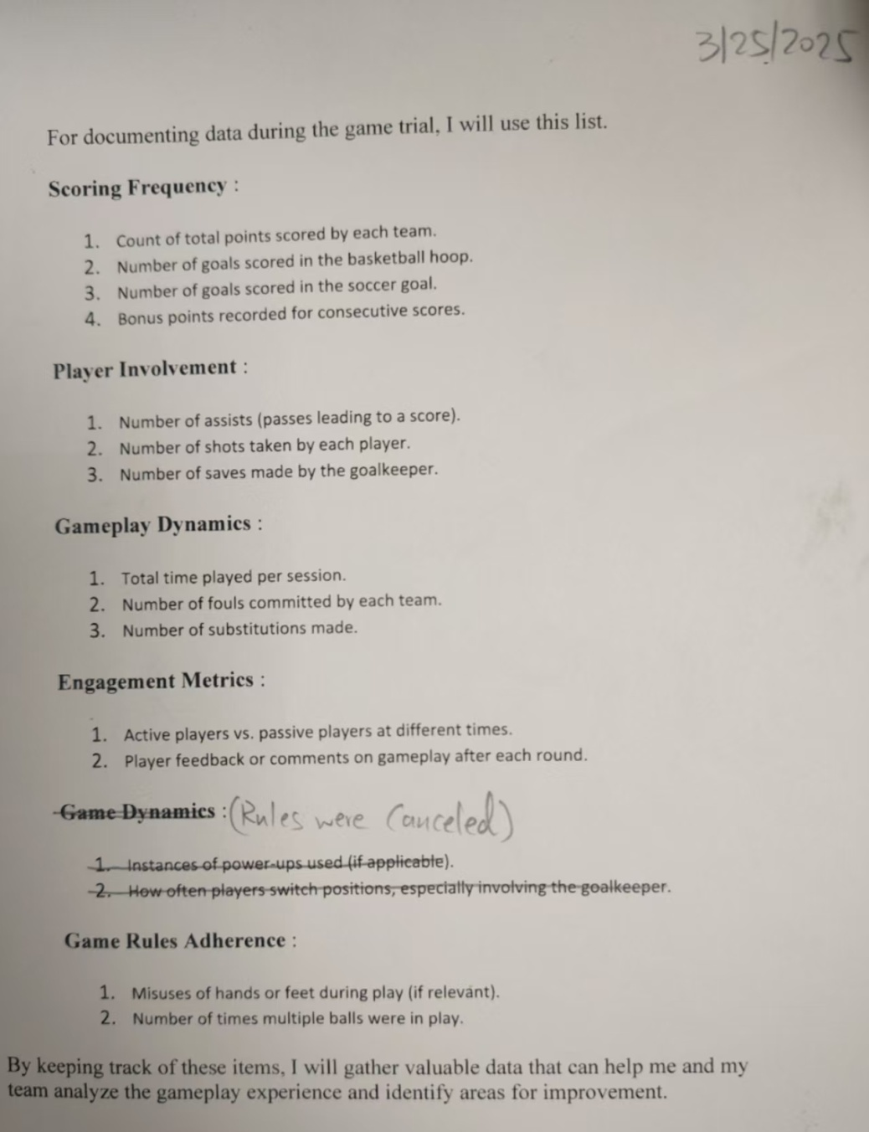

We talked about a few rules and decided to remove them since it might be too complicated.

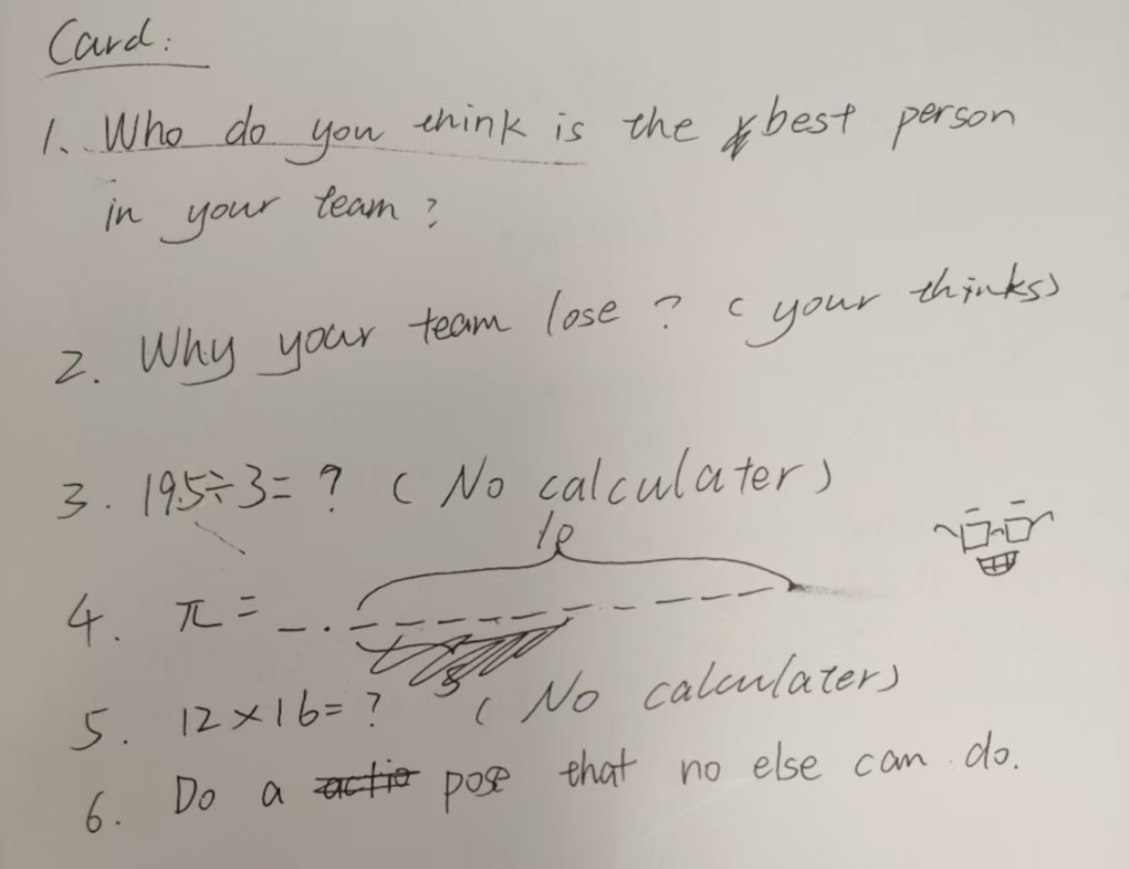

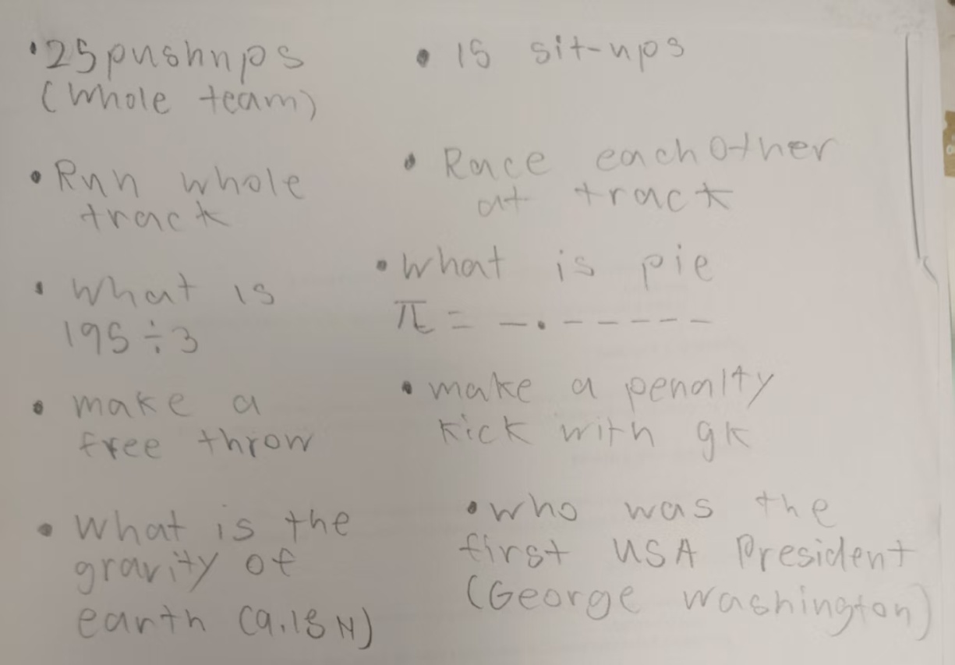

We started making some punishments and quiz for the game.

3.2 Dividing Roles

Now that we got our team and game settled, we separated roles, Chris explains the game to the users, James is the referee, Selvia takes care of the equipment, and I will record the data during the game test.

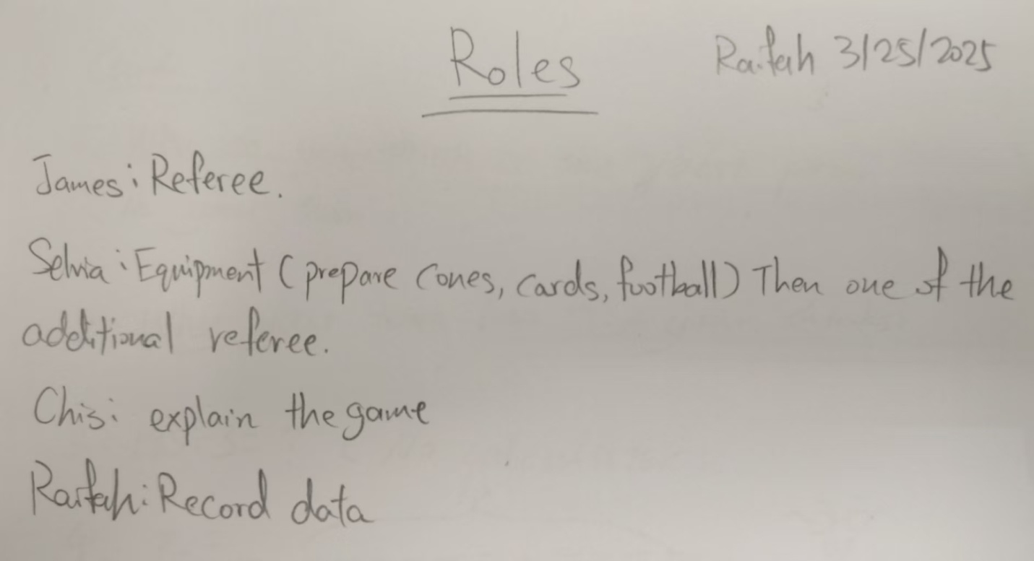

3.3 Preparing Materials and Game Explanation Graphics

As we worked on the game, I also provided some help since I made the initial design; I thought it would be good if I assisted them.

I made for the referee:

### Points Calculation Table

|  |  |  |
| --- | --- | --- |
| **Action** | **Points Awarded** | **Notes** |
| Basketball Hoop Goal | 1 Point | Bonus: +1 point for consecutive goals |
| Soccer Goal | 1 Point | No additional points for consecutive goals |
| Bonus Points for Consecutive Scores | 1 Point | Applies if a team scores two or more times in a row |
| Exchanged Goalkeeper Save | 1 Points | 1 for each player |
| Foul Committed | -1 Point | (if applicable) can be documented for player records |

### Key Rules for the Referee

**Score Tracking** :

* 1. Record each point scored in real-time to maintain an accurate score for both teams.
  2. Keep track of consecutive scoring for possible bonus points.

**Ball Management** :

* 1. Ensure players are managing one ball at a time; no player may hold two balls simultaneously.
  2. Monitor the out-of-bounds plays and enforce possession rules.

**Fouls and Conduct** :

* 1. Watch for any violations of the game rules (e.g., improper use of hands or feet).
  2. Document any fouls committed for reference during or after the game.

**Goal Kick and Throws** :

* 1. Observe the goalkeeper's actions when the ball goes out of play; the referee must decide if the throw is valid based on the last player to touch the ball.

**Gameplay Fairness** :

* 1. Ensure that all players adhere to the rules and maintain sportsmanship throughout the match.
  2. Be prepared to explain any rule violations clearly to the players.

Purpose: This reference and set of rules will help the referee in effectively managing the game and ensuring fair play. (The referee looked through this and made his own table afterwards with minor adjustments)

### I made for the game explainer:

### Game Rules for the Basketball-Football Game

**Objective** :

* 1. Teams aim to score a total of 15 points.
  2. Points can be scored by making at least 3 baskets in the basketball hoop and scoring goals in the soccer goal.

**Scoring** :

* 1. Teams must score at least three points from the basketball hoop and three points from the soccer goal to win.
  2. 1 point for scoring consecutively (continuously) for basketball.
  3. 1 point added if a player replacing the goal keeper successfully blocks a shot. Only 1 point for each player. If the goal keeper scores they get 1 extra point too. This can only be added once. (originally 1 point, because goal keeper scored, +1 point)

**Game Setup** :

* 1. The playing field consists of a basketball hoop and a soccer goal at each end, along with a designated handball zone.
  2. Two balls are used simultaneously in the game.
  3. Uses a football.

**Gameplay** :

* 1. Players can only have 1 ball during play.
  2. When balls clash and one goes out of bounds, the team responsible for the kick will lose possession of the ball that went out.
  3. If both balls go out of bounds due to a clash, the referee will review the play or jump ball to determine possession.

**Player Roles** :

* 1. Each team has specific roles, including a goalkeeper who can throw the ball back into play if it goes out from their respective zone. The goal keeper only guards the football goal.
  2. A player can exchange placed with a goal keeper after one team scored more than 5 points.

**Important Notes** :

* 1. Care should be taken to avoid confusion and ensure safety, especially given the complexity of using two balls.
  2. Players should be aware of the rules for handling the balls and switching positions as necessary.
  3. If ball goes out of bound in the football zone, the opposite team gets it and can use a throw in or kick in.
  4. If ball goes out of bound in the handball zone, the respective goal keeper does a throw in.

Purpose: By following these organized rules, team members should have a clear understanding of how to play the game effectively. (The game explainer used it as a reference and eventually explained the game in his own words)

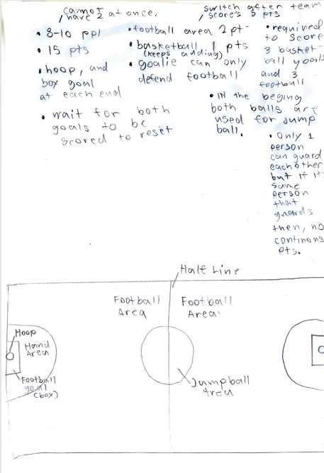 This is a list of game rules Chris made to enhance and clarify his understanding of the game. 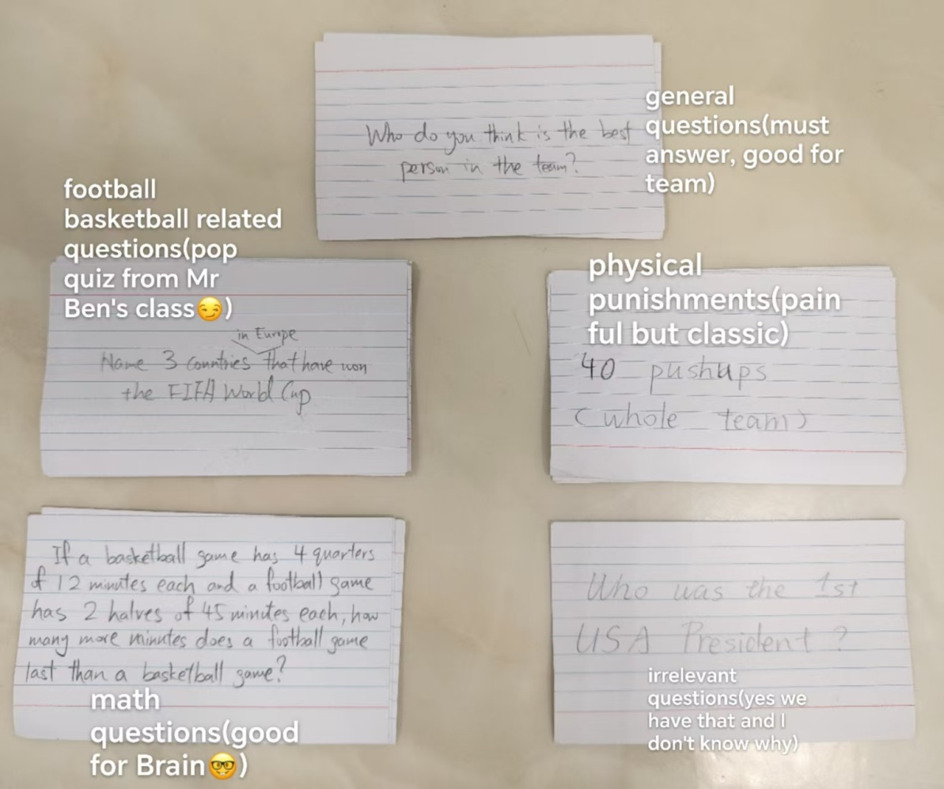 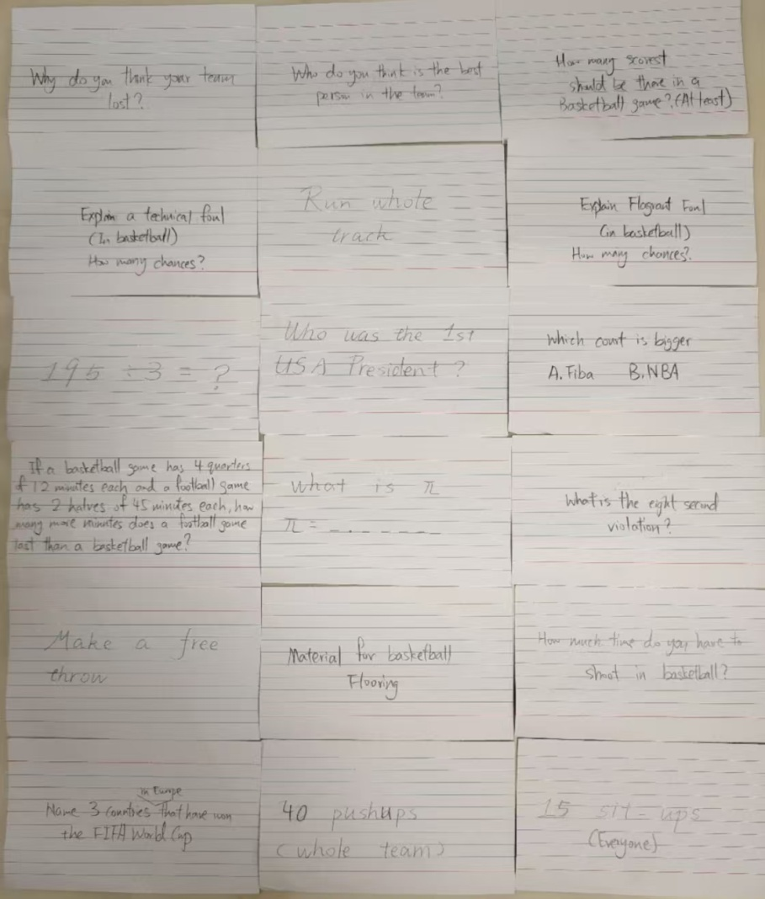

For the cards, I decided to sort them into five groups: general questions, math questions, sports related questions, and irrelevant questions. Some of the cards were adapted from our group discussion, most of the others, were written by me.

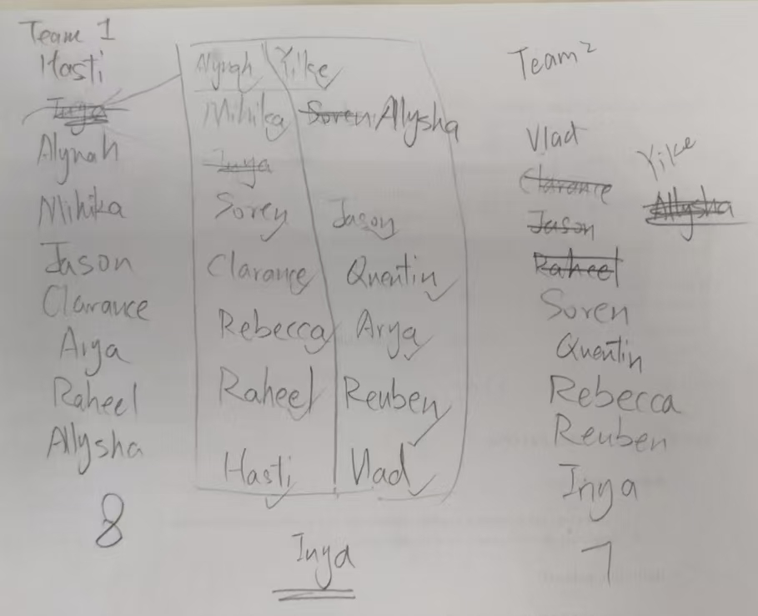

4. Evaluating

4.1 User testing

We tested our game during the PHE class. Everything worked as planned; Selvia brought 3 footballs, 4 cones a whistle, and a timer. Chris explained the game successfully; James was the referee and calculated the score with the help of Selvia. And I tried to keep track of scoring frequency. We faced some problems during the game too. Most of the players didn’t understand the game when it started; this suggested our game needed more clarification about the rules. I thought I could use 5 different colored pens to record the data, but turned out it was too complicated to switch pens and keep track of the time. Also the wind almost blew my sheets away, I had to pay attention to my surrounding or a ball may hit me. And, to my surprise, 2 referees weren’t really enough. The balls are occasionally left unattended and it was difficult to figure out which team’s ball it was, the risk of having 2 balls was considered, but we agreed that experimenting would be helpful too.

4.2 Data Analysis

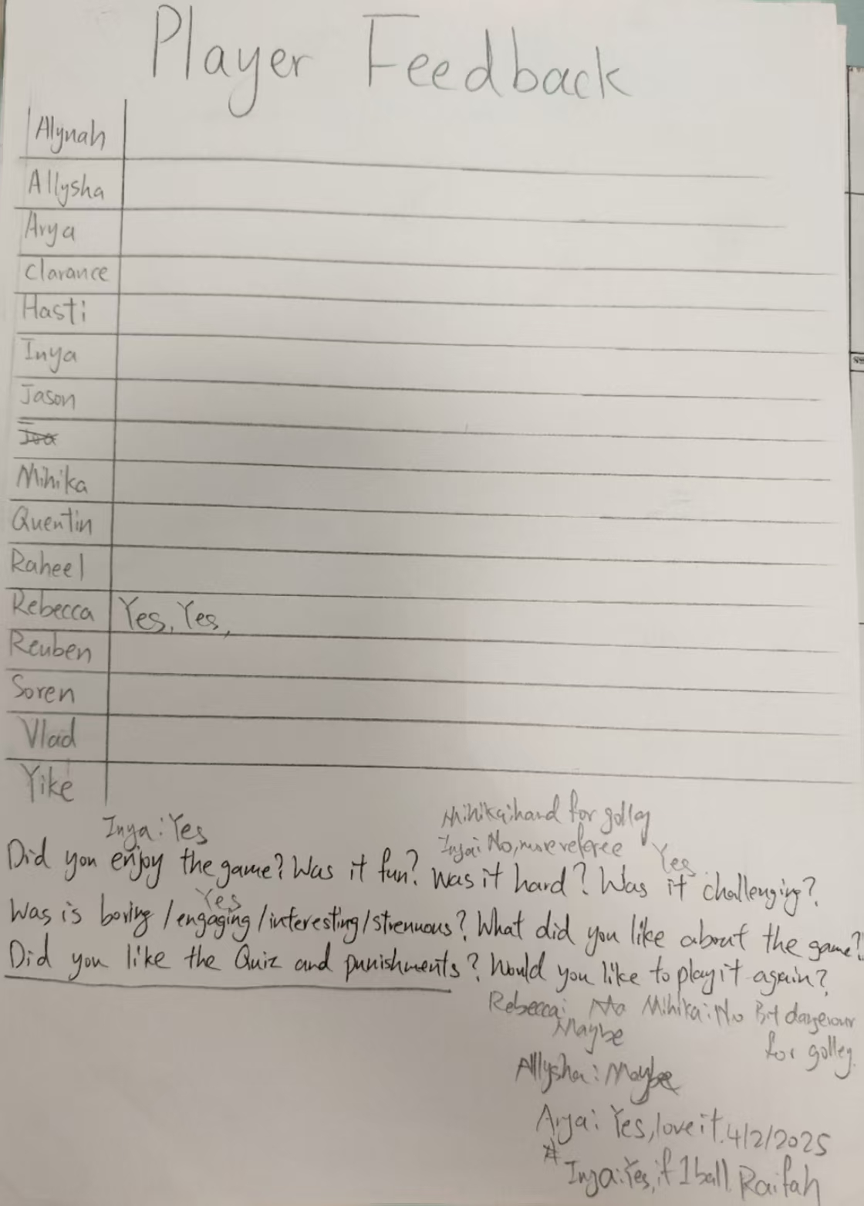

I tried to collect feedback from players after the game, but there wasn’t enough time, so I just asked anyone that was in front of me and jot down what they said. From the data, we can see that most people liked the game, and offered valuable feedback.

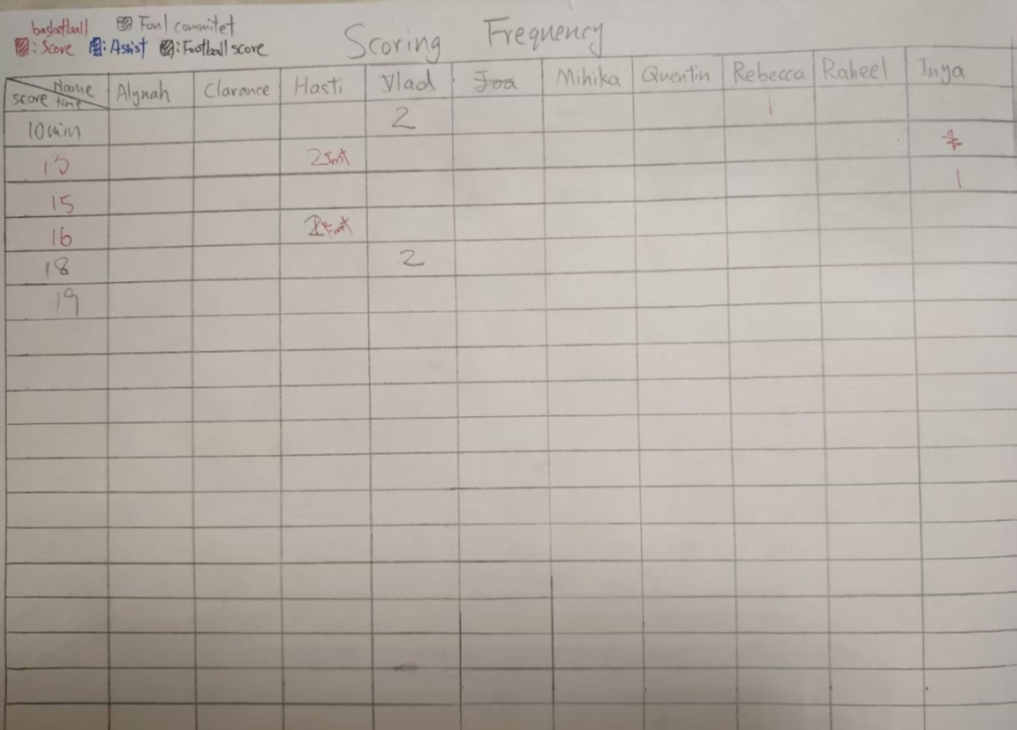

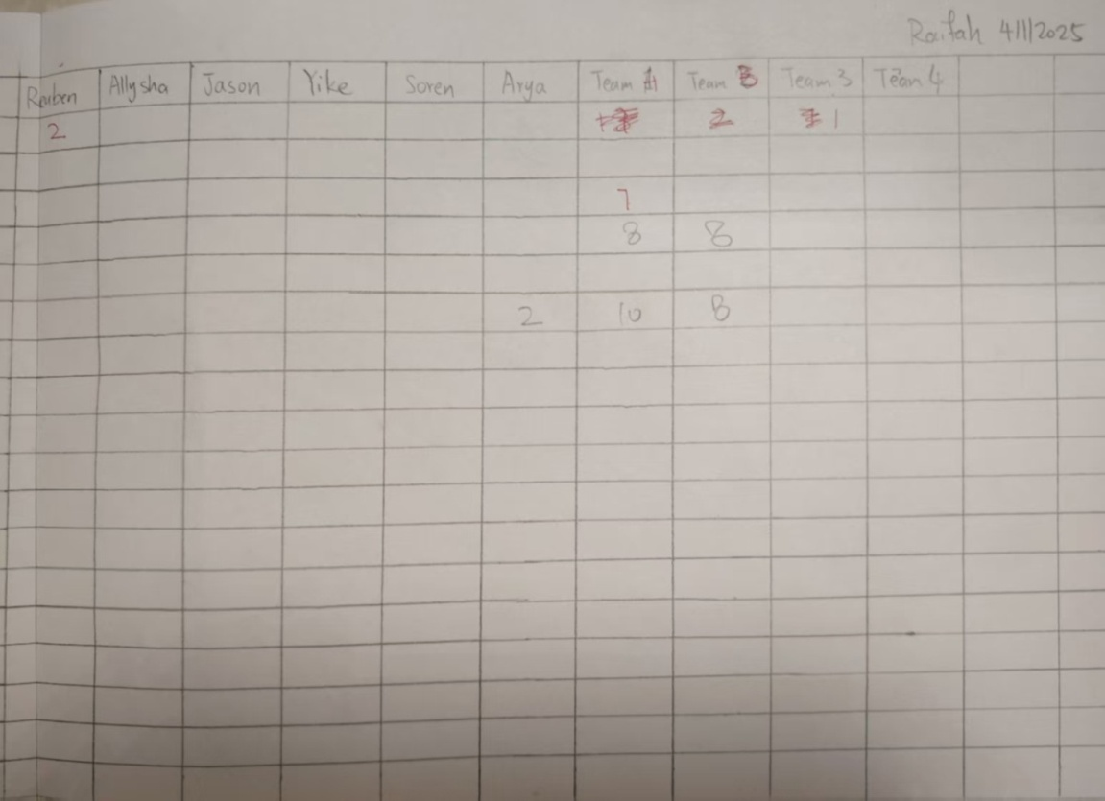

I also made a table to record the people that scored. But turned out not everyone could score so most of it was left blank. From the table, you can see Hasti, Vlad Reuben and Inya made more goals than others; however, this table cannot fully represent the player’s performances, since scoring is only one part of the game. From my observations, since there were 2 balls, many players who don’t get possession of the ball got a chance to operate, and the galleys participation also increased.

4.2Reflection and Future Improvements

I. Introduction

1. Project Recap

- This semester in the IDU class, we were meant to design a Sports game that is suitable for a diverse group and develops some physical ability. The goal of the soccer basketball hybrid game was to provide an engaging and challenging sports experience while promoting teamwork and using strategic moves.

2. Test Overview

- This test was conducted to provide feedback and show the outcomes of the game design. The game was tested with 15 players over a 40 minutes PHE block in the Basketball court. The actual game toke about 25 minutes to complete.

II. Evaluation Criteria

1. Define Metrics

- Gameplay

- Mechanics: At first, some people were unable to understand the rules and keep making fouls and hand balls. But after some time, they got used to the game. It was very interesting to see the players collaborate and switch quickly between hand and feet dribbling. The game progressed quite well, although there was a slight miscalculation in the number required for winning, that’s why we changed the points needed to 10 instead of 15 after seeing it was too much. Players also gave valuable feedback during the game like it was too hard for the goal keeper or they promptly reported any fouls committed.

- Difficulty: Despite a slightly unsuitable final score, the difficulty level seemed to be quite proper; we can see players scoring evenly as the final score settled at 10:8.

- User Experience: Although unfortunately I did not successfully collect direct feedback from all the players, some gave some feedback. Like Hasti, Jason, Arya, Clarance, Inya (if remove a ball) would like to play the game again, Rebecca and Mihika remained a bit unclear saying “maybe” and Mihika addressed the concern for defending as a goal keeper: she thinks it’s very challenging for a goal keeper and she is afraid that she would get hit by the ball that goes in the basketball hoop. Most of them enjoyed the game too; this can not only be seen from the scoring data and their feedback, but also by their casual smile appearing time to time during and after the game. Some players had specific preferences, like Hasti, who enjoyed scoring (we can see by how many goals he made) and Clarance who liked “elbow stricking” others (for some reason, although he didn’t do it in game, if he did, I am concerned). And I have to mention, the PE teacher was also very supportive, he provided some constructive feedback: He liked the idea of having a soccer and basketball goal, but maybe we could only keep one ball and remove the goal keeper, make the goal bigger, but reduce points for soccer goals. All of this, is very helpful for my reflection.

- Interface: Except for the few misinterpretations of rules at the start of the game. Most players fully understood the rules and as time passed, even got proficient in the game. With early preparation of a complete introduction to the rules, clear area and role separation, the game was not very complicated to comprehend.

- Immersion: While the results where pleasing, there is still a significant amount of players not engaged in the game. However, this is common in other games too. As for the players that were dedicated, they seemed to enjoy the game and most of them said they would like to play the game again in future. It was also wonderful to see that even after the game, the defeated team talked about who they thought did well and why did they lose with the guide of our cards made for especially after game. I can see that this was not only a growing and self-enhancing experience for me and my team, but also for the every participant. (Turning into Shakespeare now)Sport is not only a simple physical activity, but also an important part of life that connects people through it, and makes you a better person.

- Learning and Engagement

- Learning: Although we didn’t have much time, I made cards that incorporated some short quizzes about what Mr. Ben taught in his IDU class, it is a good revision of what we have learned.

- Engagement: Thankfully, there wasn’t any major stuck up in the game play. Everything was smooth and there was a power struggle between the 2 teams (since we considered the most balanced separation in teams, ok, we used coin tossing but then we made adjustments too), this made the game exciting. It was

good to see effective collaboration and some players leading and encouraging their team to score.( that’s why I forgot to record some dataL)

III. Results and Findings

1. Quantitative Data

- Present any numerical data collected during the test. For example, “[X]% of players completed the game within [time limit], while [Y]% of players reported encountering [specific issue].”

2. Qualitative Data

- Share players’ feedback, comments, and observations. Many players noted that the game was fun and they loved the combination of soccer and basketball, but several also complained about too many balls, dangerous and tiring for goal keeper, bit too hard and long.

IV. Analysis and Reflection

1. Positive Aspects

- It was great to see players working together, and although considered too complicated, I still think there were positive aspects of having 2 balls, since it significantly increased participation (so many players that don’t normally get possession of the ball had a chance) and I was able to see 1 team scoring 2 balls at the same time! Like one in a soccer goal and the other in basketball. There was even a simultaneous goal.

- Explain why these elements were effective. “The clear division of tasks and the real - time interaction features contributed to the positive experience.”

2. Negative Aspects

- Some of the rules were still a bit confusing, and the number of points needed to win was a bit too much. The 2 balls also caused some inefficiency, like although we had 2 referees (or it wouldn’t be possible) sometimes a ball will get left out of bonds for an extended period of time. IT was more difficult to spot fouls sometimes; it seemed a bit “chaotic” at first.

- I think this was primarily caused by the less time and less people to look after the balls (although there were already 2 referees).

V. Conclusions and Recommendations

1. Conclusions

- Overall, this game succeeded in many ways, the game ended in a desirable time, most players enjoyed it, it was mostly safe and players combined strategy and cooperated. Like some players entered the “hand ball zone” and immediately picked up the ball, this proved the game encouraged and developed both soccer and basketball skills at the same time. Players helped each other and actively passed the ball, transferred it back and forth between the hand ball and football area. And I have to give a special thanks to our team that also effectively organized the game with a clear separation of roles. That’s why the game went smoothly with the help of attentive, competent referees James and Selvia, clear explanation form Chris, some ideas and tables constructed by me (well that sounded weird) and good equipment preparation. My teammates never hesitated and offered many useful suggestions throughout the game design (like removing some over complicated rules, adding points for various scoring).

2. Recommendations

- For future developments, we could consider reducing the ball as well as points or removing the goal keeper and setting the hand ball zone only for basketball goals. (Like this they can practice long term shooting for football) And we can save a few minutes for some Q&A or simple questions and punishments.

4.4 Project Summary

This semester in the IDU class, our task was to design a sports game suitable for a diverse group and beneficial for physical development. We created a hybrid of basketball and football, aiming to offer an exciting sports experience that promotes teamwork and strategic thinking.

During the project, I first conducted detailed research. I compared basketball and football through Venn diagrams, studied their rules and terminology, and made surveys to understand players’ interests. These methods helped me understand the characteristics of both the sports and players' preferences, laying a solid foundation for the game design.

In the design stage, I brainstormed various ideas, drew inspiration from different sources, and refined concepts. I finally selected a design that combined elements of both sports, with two goals at each end, a hand-ball zone, and the use of two balls. This design aimed to create a complex and engaging gameplay experience, but I also considered potential issues such as complexity and safety.

When creating the solution, we formed a team and divided roles effectively. Each member was responsible for different tasks, like explaining the game, being the referee, managing equipment, and recording data. We also prepared materials such as point calculation tables and game rule documents to ensure the smooth progress of the game.

During the user testing, we found that the game had both positive and negative aspects. On the positive side, it significantly increased player participation, some players showed excellent teamwork and strategic play. However, we also encountered problems. Some players had difficulty understanding the rules at first, the number of points needed to win was too high, and the two ball system caused some management issues.

Based on the test results, we made adjustments. We reduced the winning points from 15 to 10. For future development, we plan to consider reducing the number of balls, removing the goalkeeper, and adjust the hand-ball zone to improve the game.

Overall, this project was a valuable experience. It allowed me and my team to apply our knowledge and creativity in sports game design. Although there were challenges, the positive feedback from most players and the successful demonstration of promoting sports skills made it a pleasant process. We believe that with further refinement, this game has the potential to become a popular sports game.