**Grid ball**

Grid ball was the sport I made for the GRASPS for design. So this is all the information I gathered.

Brief

Design a sport of your own. It should contain elements of football and/or basketball.

Things to consider

1. Name
2. Rules
3. Players
4. Field/court
5. Equipment
6. Roles
7. Scoring system
8. Referees/Umpires
9. Safety
10. Spectators

Questionnaire

My questions were:

Q1: Should Football improve or is it good as it is?

Q2: Should Basketball improve or is it good as it is?

Q3: Is Football your favorite/least favorite? Explain why.

Q4: Is Basketball your favorite/least favorite? Explain why.

Q5: What parts of Football do you hate? Explain why.

Q6: What parts of Basketball do you hate? Explain why.

Q7: Do you like running or not? Explain why.

Q8: Do you like hurting people in the game? Explain why.

Q9: Do you like the football design?

Q10: Do you like the Basketball design?

Answers:

|  |  |  |  |  |  |  |  |  |  |  |
| --- | --- | --- | --- | --- | --- | --- | --- | --- | --- | --- |
| People | Q1 | Q2 | Q3 | Q4 | Q5 | Q6 | Q7 | Q8 | Q9 | Q10 |
| Allyssha | Maybe | Maybe | It’s Ok | It’s Ok | Not good at it | Not interesting | No | No | Maybe | Maybe |
| Arya | Good | Good | Favorite | Maybe | Nothing | Nothing | yes | no | Yes | Yes |
| Inya | 50/50 | no | 50/50 | Yes she likes it | It will hurt | No | 50/50 | No | 50/50 | Yes |
| Jason | Good | Good | Yes | yes | No | No | Yes no? | Yes | No | Yes |
| Raheel | Good | Good | Favorite | least | All | No | Yes | Yes | N/A | N/A |
| Reuben | No | No | Yes Fun | Yes Fun | Violent kick | Nothing | Yes | No | Yes | N/A |
| Yike | N/A | N/A | N/A | N/A | N/A | N/A | N/A | N/A | N/A | N/A |

Venn Diagram

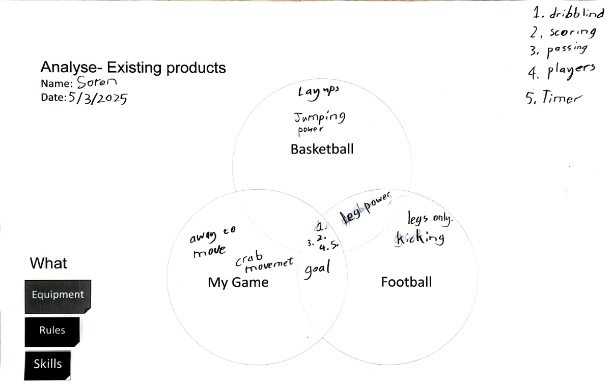

Research

I asked the A.I. program DeepSeek for assistance using this prompt: “Give me a short explanation, a few sentences only, for the following list for the sports of Football & Basketball:

1. Name
2. Rules
3. Players
4. Field/court
5. Equipment
6. Roles
7. Scoring system
8. Referees/Umpires
9. Safety

10) Spectators

These are the answers it returned.

A-Football

1) Origin of Name: The name "football" comes from the sport being played on foot (as opposed to on horseback) and involves kicking a ball.

2) Rules: Governed by FIFA, rules include no hands (except goalkeepers), offside, fouls, yellow/red cards for misconduct, throw-ins for out-of-bounds, goal kicks, corner kicks, and match duration (90 minutes split into two halves, plus added time).

3) Players: Two teams of 11 players each, including a goalkeeper, defenders, midfielders, and forwards.

4) Field/Court: A rectangular grass or artificial turf field, typically 100-110 meters long and 64-75 meters wide, with goal areas and penalty boxes.

5) Equipment: Ball, goalposts, cleats, shin guards, and team uniforms.

6) Roles: Players have specific positions and responsibilities, such as scoring (forwards), defending (defenders), and playmaking (midfielders).

7) Scoring System: Goals (1 point each) are scored by getting the ball into the opponent's net.

8) Referees/Umpires: One main referee, two assistant referees, and a fourth official enforce rules, monitor offside, and ensure fair play.

9) Safety: Protective gear like shin guards, fair play rules, concussion protocols, and medical staff ensure player safety.

10) Spectators: Fans watch in stadiums or on TV, creating a vibrant atmosphere and supporting teams.

So I thought about all the elements of both games and used an idea I had from playing with my friends last year. And I came up with a new game.

So we then have to make teams and my sport won the vote against my teammates sports

Team members

Soren

Jason

Arya

Reuben

01/04/2025 Made a WeChat group so we can discuss ideas.

Possible names for our game:

1. GridBall
2. BounceNet
3. GridGoal
4. NetRush
5. BoundZone
6. ZoneBall

We decided on Grid Ball by voting on a Wechat group

Field/Court

The court is a grid with squares and with narrow boundaries between each of the squares. There is a net on the left and the right of the court for scoring.

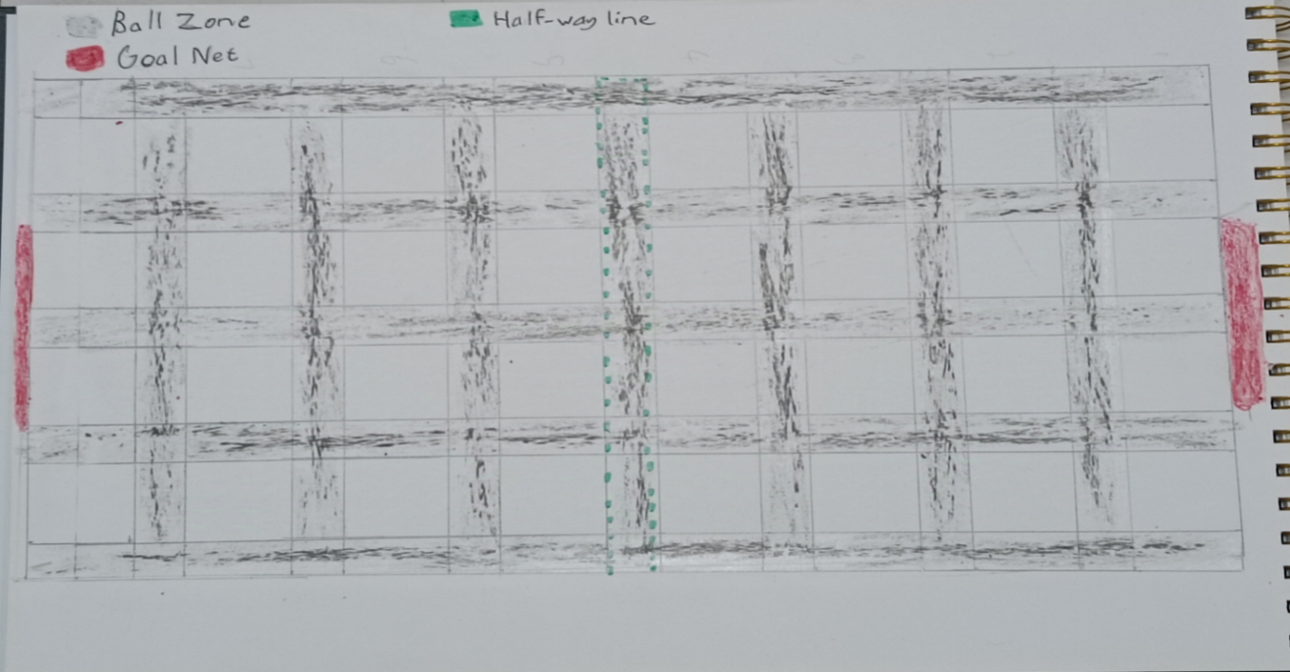

Objective

Teams must bounce a ball on the narrow boundaries called the Ball Zone so that they can score a goal by throwing the ball into the net at the opposite end. Each goal is worth 1 point. Winner is the team with the most points after 15 minutes.

Players

Two teams, each team has five members.

2 x Defenders

2 x Attackers

1 x Goal Keeper

Rules

The players can only move on the narrow boundaries (Ball Zone) between squares and cannot step into the squares. Except for the Goal Keeper.

The player with the ball can only bounce the ball within the Ball Zone (narrow boundaries).

The player can only throw the ball to another player.

If the ball lands on a square it can be picked up by any team but no one can step into the square to get it.

Attackers can only stay on the other team’s half of the court.

Defenders cannot leave their half of the court.

Referees

There are going to be 4 referees

1. Attacker referee-Arya
2. Defender referee-Reuben
3. Goal keeper referee-Jason
4. Timer referee-Soren

Each referee will give the player who broke the rules a “GET OFF THE GRID” card. The Player will then give the card to the timer referee who will set the timer to 2 minutes.

When the timer runs out, the timer referee will give the card back to the player.

The player returns the card to the referee who gave it to him in order to return to the grid.

The referees will be wearing a black T-shirt with a blue armband.

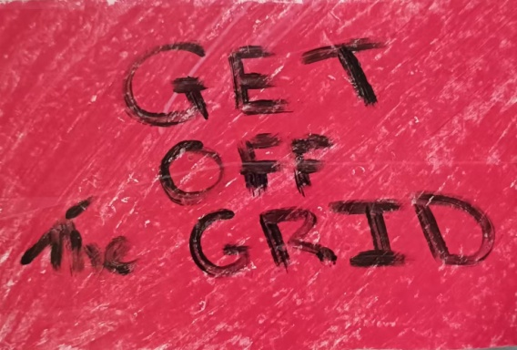

Evaluation

First I must say that I enjoyed doing this project. It was fun because we make up games anyway all the time, so I feel like an expert. I was really proud that the team chose my game. So during the team stage I tried to lead. I don’t know if they listened to me or not but I tried.

I thought my game was well organised, but it wasn’t such a success. I think this was mainly because of two problems.

1. We were confused about which day it would played. We thought our game was set for Thursday, but it happened, to our surprise, on Monday. That meant we did not have time to rehearse our plan to explain it to the players and we didn’t have our uniforms (black T-shirts and blue armbands with us).
2. The second problem was that the players were just kicking footballs around and not listening to us explain the rules. That is why there was confusion during the gameplay.

Next time I can solve these problems by being more prepared on the day (if I know the actual day). I can also tell the referees to break the teams up and each referee can explain the rules to each team separately. That way there are fewer people to explain to each time. Each group can ask questions to their referee before beginning. I think we should have a quick 5 minute practice game so everyone gets the general idea.