Refugee Child toy

Raifah, 6/15/2025

A GRASPS and ATL integrated project

Table of Contents

1. Inquiring and Analyzing 2

1.1 Explain and Justify the Need 2

1.2 Identify and Prioritize the Research 4

1.3 Analyze Existing Products 2

1.4 Develop a Design Brief 2

Bibliography 7

2. Developing Ideas 8

2.1 Develop a Design Specification 8

2.2 Develop Design Ideas 8

2.3 Present the Chosen Design 8

2.4 Develop Planning Drawing/ Diagrams 8

3. Creating the Solution 8

3.1 Construct a Logical Plan 8

3.2 Demonstrate Technical skills 8

3.3 Follow the plan to make the solution 8

3.4 Issues Faced 8

3.5 Justify the Changes Made to the Design 8

4. Evaluating 8

4.1 Design Testing Methods 8

4.2 Evaluate the Success of the Solution 8

4.3 Explain How the Solution Could Be Improved 8

4.4 Explain the Impact of the solution 8

Statement of Inquiry

To create a fairer world, we must first evaluate and understand the needs of different communities.

GRASPS Standards

GOAL:

Design and create a prototype toy that enhances play opportunities for refugee children aged 6-12, considering cultural sensitivity, durability, and accessibility. The toy should promote emotional well-being and/or learning through play.

ROLE:

You are a humanitarian product designer working for "Design for Change," an international organization that creates solutions for children in crisis. Your team has been tasked with developing innovative toy designs that can be implemented in refugee camps.

AUDIENCE:

Primary: Refugee children aged 6-12 in temporary housing facilities.

Secondary: Aid organisations and nongovernment organisations who will implement your design. Stakeholders: Parents, camp administrators, and child development specialists

SITUATION:

Recent reports show a critical lack of play opportunities in refugee camps, affecting children's emotional and social development. Your design team needs to create a toy that:

•Can be produced using 3D printing technology

•Is durable and safe for long-term use

•Considers limited resources in refugee settings

•Promotes positive play experiences

•Is culturally sensitive and inclusive

PRODUCT/PERFORMANCE:

A Design Portfolio should be created including:

•Research findings and needs analysis

•Design specifications

•Sketches and iterations

•TinkerCAD 3D design files

•Material considerations

•Cultural sensitivity analysis

•Testing results

Physical/Digital Deliverables:

•3D printed prototype

•User instructions in multiple formats

•Implementation guide

STANDARDS (Based on MYP Design Objectives):

Objective A: Inquiring and analysing

i. explain and justify the need for a solution to a problem.

ii. develop a design brief, which presents the analysis of relevant research.

Objective B: Developing ideas

i. develop a design specification, which outlines the success criteria for the design of a solution based on the data collected.

ii. present a range of feasible design ideas, which can be correctly interpreted by others.

Objective C: Creating the solution

i. demonstrate excellent technical skills when making the solution.

ii. follow the plan to create the solution, which functions as intended.

Objective D: Evaluating

i. explain the success of the solution against the design specification.

ii. describe how the solution could be improved

Approaches to Learning (ATL)

• Communication skills

• Practice empathy

• Listen actively to other perspectives and ideas.

• Collaboration skills

• Keep an organized and logical system of information files/notebooks.

• Creative-thinking skills

• Create novel solutions to authentic problems.

• Make unexpected or unusual connections between objects and / or ideas.

• Apply existing knowledge to generate new ideas, products or processes.

Learner Profile attributes

• Open minded – we critically appreciate our own cultures and personal histories, as well as the values and traditions of others. We seek and evaluate a range of points of view, and we are willing to grow from the experience.

Understanding these requirements is crucial for the design since you will have a standard and clear objective while working on the project.

## 1.2 Identify and Prioritize the Research

To understand the user needs, we did various activities that require our ATL skills. In April 8th, we first started with an exercise called “empathy, think, pair, share”, where we answer questions related to home using our five senses. Here are the questions:

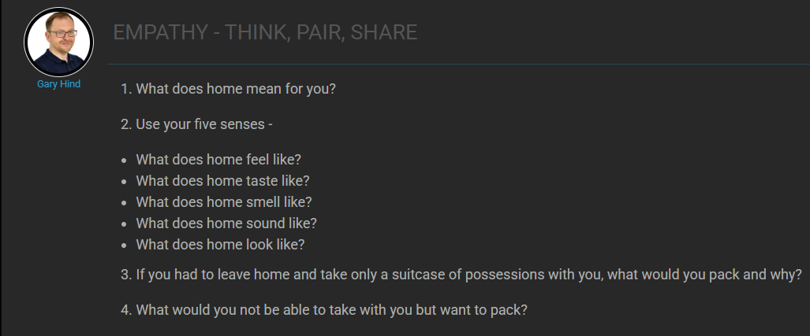

And here are my answers:

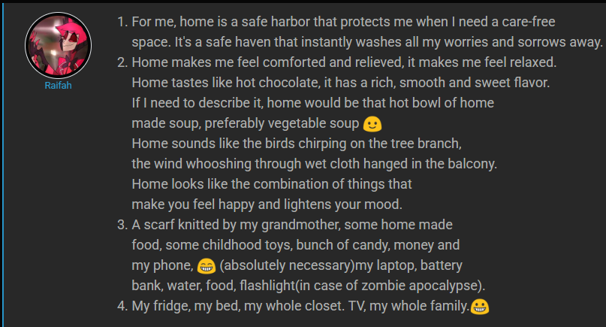

By describing qualities you think a home should have using diverse perspectives (touch, taste, scent, sound, view), and considering items you would need if you had to leave your home, we are refering to the situation our primary users are facing, and this can help us understand the user need and know what the expected outcome of the product should be. For instance, bring a feeling of home, or meet the needs of these refugee kids.

Then, at the same day, we did some research surrounding the topic on refugees, concerning their number and reason for the occurance of increased refugee in certain countries.

Here are the main findings:

1.Why are there so may refugees coming from Syria, Afghanistan, Somalia, Myanmar and South Sudan?

Mainly because:

1) People are fleeing their countries to seek safety

2) Neighbouring countries have taken in the majority of refugees– but they can only do so much

3) Lack of legal routes to safety [1]

2. How many refugees are children?

In Syria, there are more than 7 million children in need [2].

In Afghanistan, there are 47 million children refugees and 2 million of them were born refugees [3].

In South Sudan, an estimated 476000 [4] children are refugees.

In Myanmar, 37% of the 1,183,300 Refugees and asylum-seekers are children.

In Somalia there are 35,461 refugees and some of them are children.

Worldwide, about 49 million children are refugees, 2.3 million were born refugess. Between 2018 and 2024, an average of 337800 children were born as refugees per year.

Then, in 15th April, we were assigned in teams to “peel the fruit” were we need to examine photos to go deeper step by step.

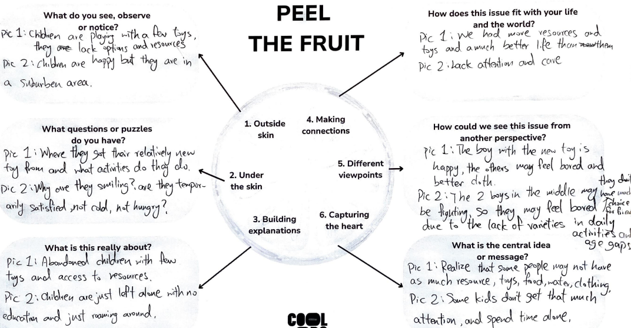

After me, Silvia, James and Chris looked at these pictured and filled out the paper, we learned to have a new perspective and gradually go deeper while analyzing.

Then in

# 2. Developing Ideas

## 2.1 Develop a Design Specification

## 2.2 Develop Design Ideas

## 2.3 Present the Chosen Design

## 2.4 Develop Planning Drawing/ Diagrams

# 3. Creating the Solution

## 3.1 Construct a Logical Plan

## 3.2 Demonstrate Technical skills

## 3.3 Follow the plan to make the solution

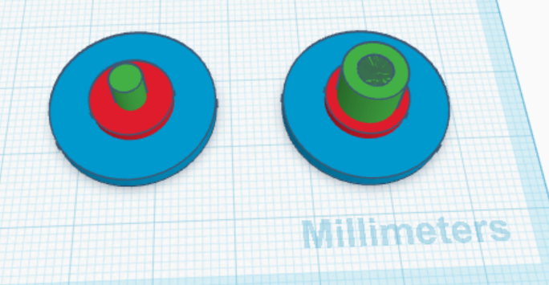

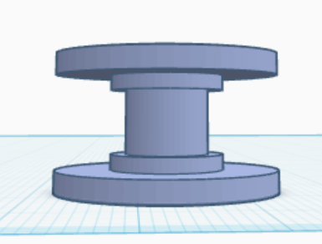

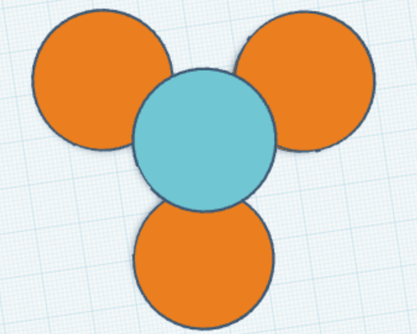

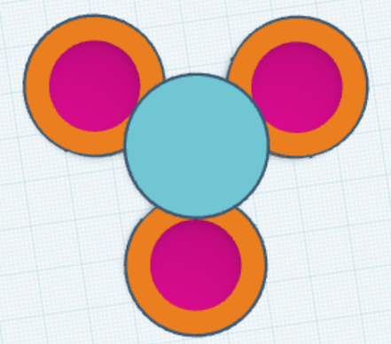

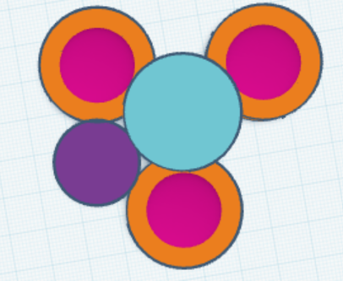

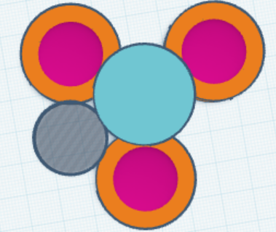

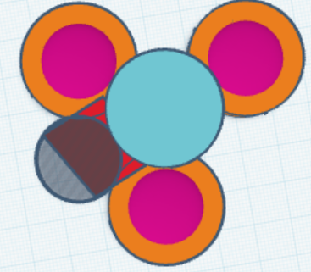

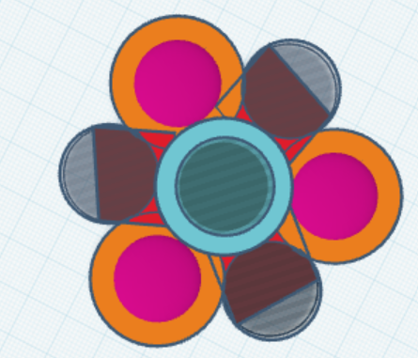

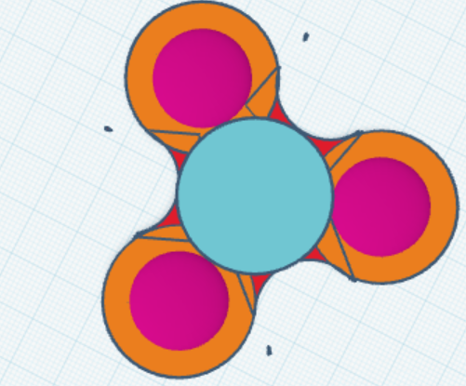

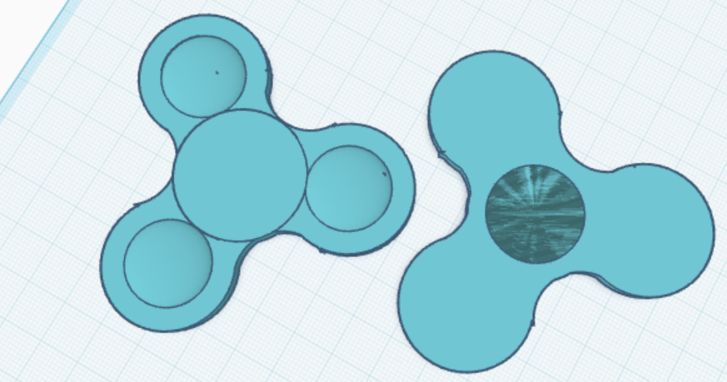

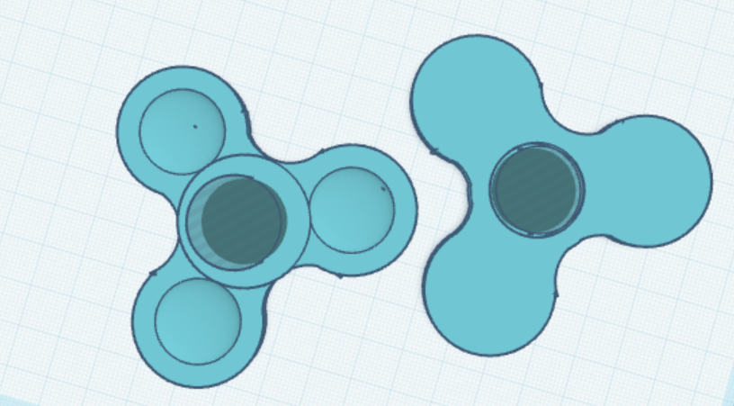

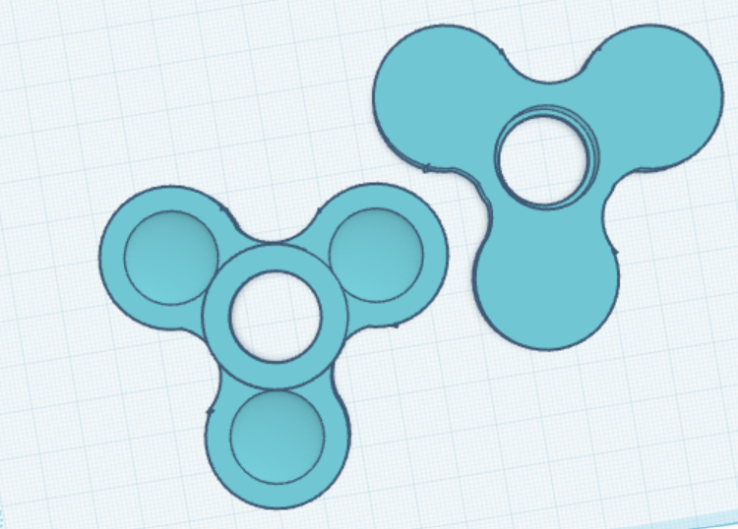

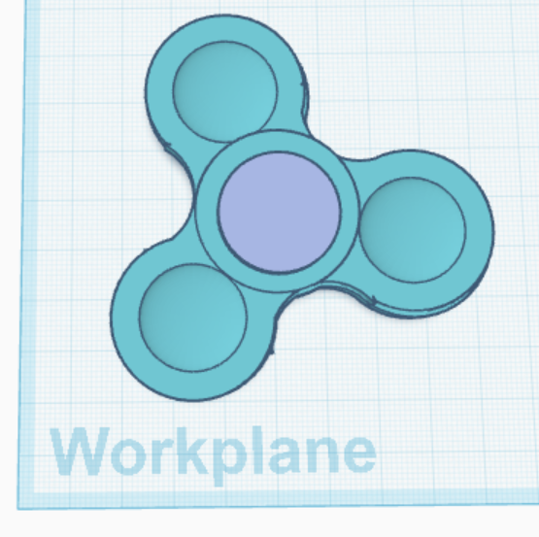

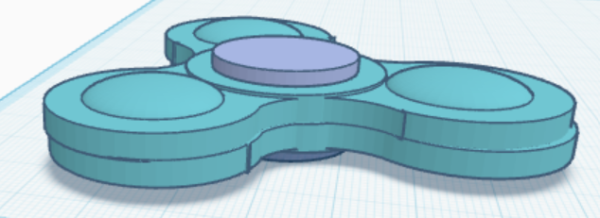

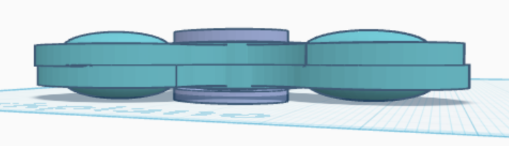

## 3.4 Issues Faced

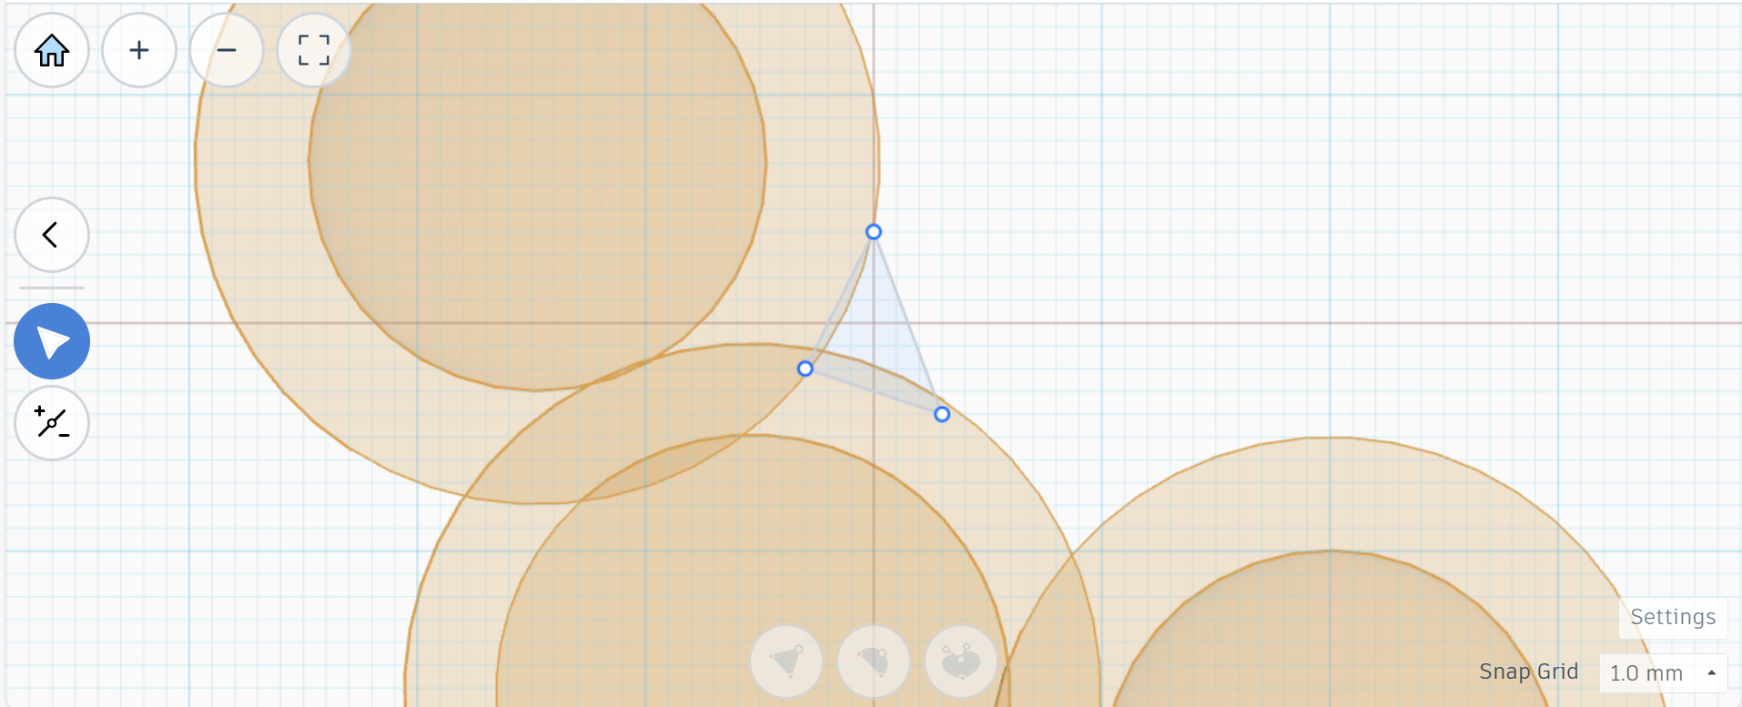

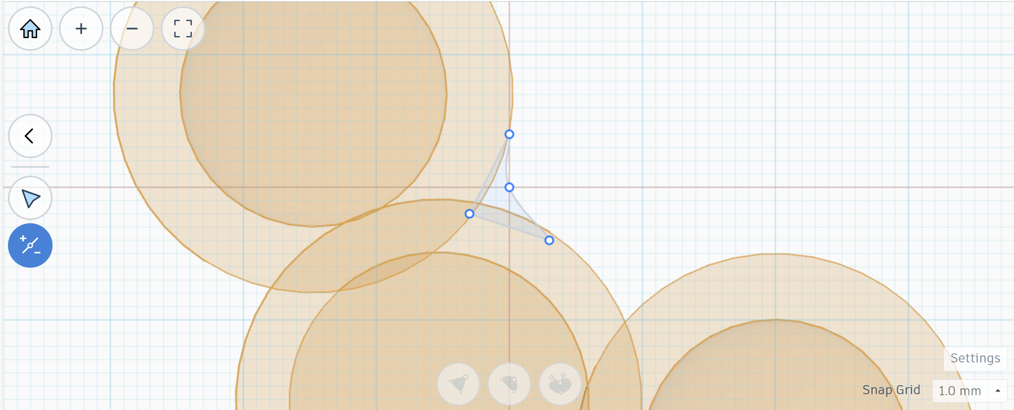

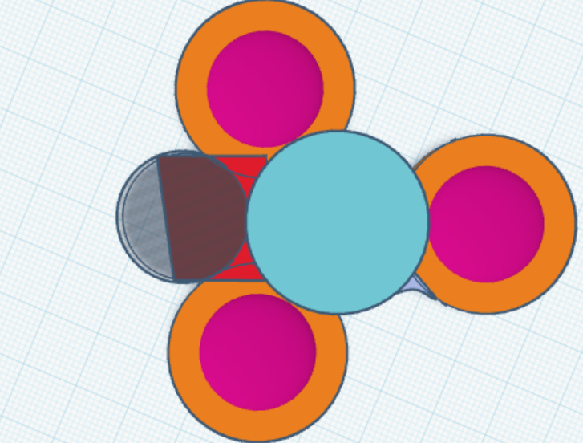

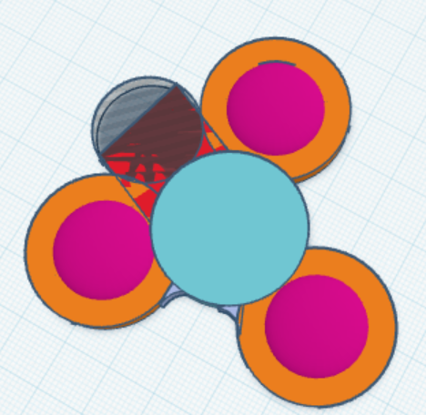

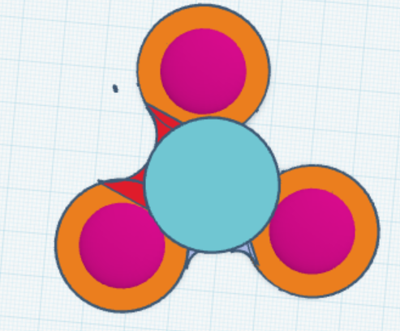

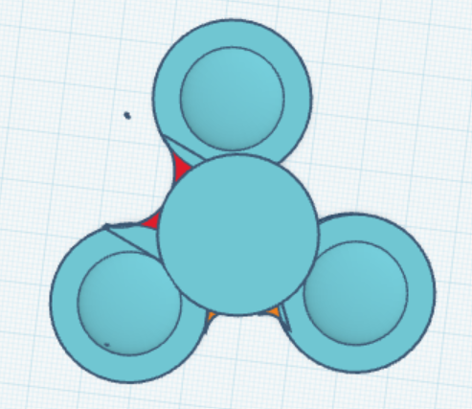

## 3.5 Justify the Changes Made to the Design

# 4. Evaluating

## 4.1 Design Testing Methods

## 4.2 Evaluate the Success of the Solution

## 4.3 Explain How the Solution Could Be Improved

## 4.4 Explain the Impact of the solution